

VELOCE ANG PATRIOT (INSERT ICAO CODE)

transition & Recurrent TRAINING GUIDE

Version 1.0

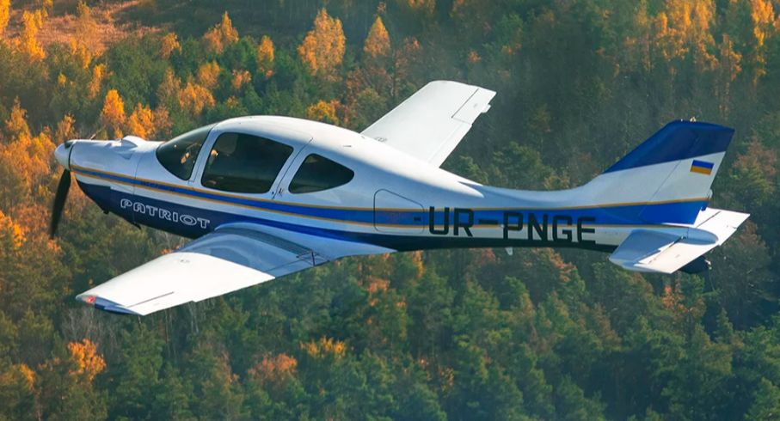

VERSION HISTORY

Version  Number | Implemented  By | Revision  Date | Approved  By | Approval  Date | Description of  Change
1.0 | Matt Speare | 2/15/2025 |  |  | Initial Draft

Table of Contents

Veloce ANG LNC4 Training Guide (IV/IVP/IVP-T) 1
TRAINING GUIDE 1
Version 2.0 1
9/04/2023 1
VERSION HISTORY 2
1.0 Introduction 4
1.1 Background and Scope 5
1.2 Points of Contact 6
1.3 training prerequisits 6
1.4 training guide structure 6
1.5 FITS Terminiology 7
2.0 Training Requirements 9
2.1 ground training tasks and grading 9
2.2 flight training tasks and grading 10
2.3 personal minimums 11
3.0 Instructional Methods 15
3.1 recommended sequence of training sessions 15
Lesson G1 - Ground 16
Lesson F1 - Flight 18
Lesson G2 - Ground 21
Lesson F2 - Flight 22
Lesson G3 - Ground 25
Lesson F3 - Flight 26
Lesson F3I - Flight 29
Lesson F4I - Flight 32

Lesson F4V - Flight 35
Lesson F5I - Flight 38
Lesson F5V - Flight 41
Lesson F6I - Flight 44
Lesson F6V - Flight 47
Lesson RG1 -Ground 50
Lesson RF1 - Flight 53
Lesson RFI2 - Flight 56
Lesson RFV2 - Flight 59

4.0 Training Resources 63
4.1 Course Administration 63
4.2 Qualified Instructors 63
4.3 Proven Safety Record 63
5.0 Supplemental Material 64

1.0 Introduction and airframe overview

This Veloce ANG 01 Patriot initial transition flight training syllabus is based on modern FAA/Industry Training Standards (FITS) that train to proficiency utilizing scenario-based training modules combined with classic maneuver-based training. Sound aeronautical decision making, single pilot resource management and risk management is emphasized throughout this program. This training syllabus provides initial flight and ground transition training for a pilot who has no prior ANG experience or recurrent training for an experienced ANG pilot.
The ANG 01 Patriot is an all-carbon fiber, 5-seat airplane, retractable gear airplane designed to maximize performance and comfort. An empty weight of 838 lbs (380 kg) and maximum takeoff weight of 2094 lbs (950 kg) result in useful loading of 1262 - 1500 lbs (570 kg). With a width 52 inches and height of 47 inches result in a very comfortable cabin which is 7 inches wider than a Cirrus SR22. The ANG was designed to be powered by a Rotax 915 iS or EP 918 Ti.
The airplane is designed for safe operations, with increase flap area to reduce takeoff and landing speed to 43 kts. The airplane is equipped with airborne warning systems to reduce pilot errors such as forbidden takeoff weight or unsafe landing gear. The airplane is also equipped with a modern GRS 6 800-990 SDS parachute rescue system manufactured by Czech company Galaxy GRS.
- General Specs (ANG 01 Patriot): – 5 Passengers, Wingspan 31 ft 6 in, Max Gross Weight 2,094 lbs, Fuel Capacity 65 US Gal, 110 US Gal with extended tanks.
- Performance Specs:
Specification | Rotax 915 iS | EP 918 Ti
Engine | Rotax 915 iS | EP 918 Ti
Horsepower | 141 HP | 185 HP
Cruising Speed | 186 KTAS | 200 KTAS
Operating Altitude | 12,000 ft | 12,000 ft
Fuel Consumption | 10 gph | 10 gph
Max Range | 1200 nm | 1200 nm
Useful Load | 1,252 lbs | 1,500 lbs
Stall Speed | 43 knots | 43 knots

1.1 Background and Scope
This document is intended for use by Certified Flight Instructors and Veloce ANG Pilots for use in a course of instruction to train pilots in the ANG series aircraft. The documentation for this course material is not complete without:
- Veloce ANG 01 Patriot Training Guide (this document)
- Aircraft Specific Pilots Operating Handbook (POH)

The material contained herein is designed to either transition a current, proficient and qualified certificated pilot into the Veloce ANG Series amateur built experimental aircraft or to conduct annual recurrent training to an experienced Veloce ANG pilot. This manual covers a variety of topics related to high performance single pilot, single engine flying, including: weather, aerodynamics, aircraft performance, physiology, navigation, and Veloce ANG aircraft systems.
This manual does not cover every conceivable instrument or radio installation or engine or airframe modification. For example, early serial number Veloce ANG Series were equipped by owner/ builders with steam gauge cockpits whereas today most are finished with EFIS cockpits. Many modifications to the basic airframe have also occurred both with builders and at the factory.
While this manual covers many technical aspects of flying the Veloce ANG Series, it does not ignore the most important and most often the weakest link in airplane—the pilot. Flying is an extremely hazardous activity. The risk of flight can be managed to an acceptable level if the pilot is willing to invest the time, effort and financial resources to stay proficient. Like any other extreme sport, flying demands continuous study, training, practice and review. This is especially true of flying aircraft like the Veloce ANG IV Series.
This Veloce ANG initial transition flight training syllabus is based on modern FAA/Industry Training Standards (FITS) that train to proficiency utilizing scenario-based training modules as well as classic maneuver-based training. Sound aeronautical decision making, single pilot resource management and risk management is emphasized throughout this program. This training syllabus provides initial flight and ground transition training for a pilot who has no prior Veloce ANG experience. This training prepares a proficient certificated pilot to fly the Veloce ANG series aircraft. It does not teach basic flying skills.
This training program teaches normal as well as emergency procedures with an emphasis on sound aeronautical decision making.
38

NOTE: This syllabus does not teach VFR‐only pilots the instrument flying skills necessary to safely fly in Instrument Meteorological Conditions (IMC). VFR‐only pilots are encouraged to seek appropriate instruction to earn an instrument rating.

1.2 Points of Contact

For more information, contact:

VELOCE PLANES

www.VelocePlanes.com
jamie@veloceplanes.com
773-620-9500

1.3 training prerequisites
The PT must hold at least a private pilot airplane single engine land certificate and have a current valid airman’s medical certificate. The PT must complete all prerequisite course material before beginning the flight and ground training syllabus below. The PT will be the Pilot in Command per 14 CFR 91.3 for all flights, if qualified.

1.4 training guide structure
This training guide provides the task lists for the instructor and PT to utilize for both Initial (Transition) and Recurrent Training, and provides a scenario-based guide for the instructor to use to ensure that the PT exits the training with a demonstrated competence to operate the airframe safely throughout all appropriate modes of flight.
This structure uses a Learner Centered Grading methodology. Desired Pilot in Training (PT) Scenario Outcomes‐ The object of scenario‐based training is a change in the thought processes, habits, and behaviors of the PT during the planning and execution of each scenario. Since the training is learner centered, success is measured in the following desired PT outcomes:
Maneuver, Skill or Task Grading
- Not Observed (NO) - Any activity not accomplished or required.
- Not Applicable (NA) – Any activity which is not applicable to the airframe/systems or for which the PT is not rated.
- Explain (E) – At the completion of the scenario the PT will be able to describe the scenario activity and understand the underlying concepts, principles and procedures that comprise the activity. Instructor assistance is required to successfully execute the maneuver.
- Describe (D) - At the completion of the scenario, the PT will be able to describe the physical characteristics and cognitive elements of the scenario activities. Instructor assistance is required to successfully execute the maneuver.
- Manage/Describe (MD) – At the completion of the scenario, the PT can correctly gather the most important data available both within and outside the cockpit, identify possible courses of action, evaluate the risk inherent in each course of action Practice, and make the appropriate decision. Instructor intervention is not required for the safe completion of the flight
- (P) - at the completion of the scenario the student will be able to plan and execute the scenario. Coaching, instruction, and/or assistance from the Certified Flight Instructor (CFI) will correct deviations and errors identified by the CFI.
- Perform (P*) - At the completion of the scenario, the PT will be able to perform the activity without assistance from the instructor. Errors and deviations will be identified and corrected by the PT in an expeditious manner. At no time will the successful completion of the activity be in doubt. “Perform” will be used to signify that the PT is satisfactorily demonstrating proficiency in piloting and systems operation skills.

1.5 fits terminology

In an effort to develop a common training vocabulary, below you will find several terms describing known, but perhaps not previously defined, training concepts.

Aircraft Automation Management – The demonstrated ability to control and navigate an aircraft by means of on‐board automated systems.

Automated Navigation Leg – A flight of 30 minutes or more conducted between two airports in which the aircraft is controlled primarily by the autopilot and the on‐board navigation systems.

Automation Competence – The demonstrated ability to understand and operate the automated systems installed in the aircraft.
Automation Surprise – An automated system’s ability to provide different cues to pilots when compared to the analog systems they replace, especially in time‐critical situations.

Automation Bias – The relative willingness of the pilot to trust and utilize automated systems.

Candidate Assessment – A system of critical thinking and skill evaluations designed to assess a PT’s readiness to begin training at the appropriate level.

Critical Safety Tasks/Events – Those mission‐related tasks/events that if not accomplished quickly and accurately, may result in aircraft damage, injury, or loss of life.

Datalink Situational Awareness (SA) Systems – Systems that provide real‐time weather, traffic, terrain, and/or flight planning information to the cockpit. This information may be displayed on the Primary Flight Display (PFD), Multi‐Function Display (MFD), or other related cockpit displays.

Emergency Escape Maneuver – A maneuver (or series of maneuvers) performed manually or with the aid of the aircraft’s automated systems that allows a pilot to successfully escape from an unanticipated flight into Instrument Meteorological Conditions (IMC) or other life‐threatening situation.

FAA/Industry Training Standards (FITS) – A non‐regulatory system of training jointly developed by the FAA and training experts in the general aviation industry. Instead of training pilots to pass a practical test, FITS trains pilots to manage real‐world challenges with scenario‐based training. The primary goals of FITS‐based training scenarios is to enhance GA pilots’ aeronautical decision making, risk management, and single pilot resource management skills without compromising basic stick and rudder skills.

Generic FITS – These standards cover broad categories of training functions, such as flight reviews, complex/high‐performance training, tail wheel training, and instructional exercises. Individual training entities (e.g. flight instructors, pilot schools) may adapt them for a particular aircraft or other scenarios.

Mission Related Tasks – Those tasks required for the safe and effective accomplishment of the flight.

Multi‐Function Display (MFD) – A device that combines primarily navigation, systems, and situational awareness (SA) information onto a single electronic display.

Primary Flight Display (PFD) – A device that combines the primary six flight instruments plus other related navigation and situational awareness (SA) information into a single electronic display.

Proficiency Based Qualification – A qualification based on demonstrated performance rather than other flight time or experience.

Pilot in Training (PT) – The qualified pilot receiving training in a specified training program. Also referred to as “learner”.

Scenario‐based Training (SBT) – Training programs built around highly structured scripts of “real‐world” experiences to address flight‐training objectives in an operational environment. Such training can include initial training, transition training, upgrade training, recurrent training, and special training. The appropriate term should appear with the term "Scenario‐based," e.g., "Scenario‐based Transition Training," to reflect the specific application.

Simulation – The use of animation and/or actual representations of aircraft systems to faithfully replicate the flight environment.

Single‐Pilot Resource Management (SRM) – The “art and science” of managing all available resources to ensure the successful outcome of the flight.

Specific FITS – A FITS program tailored for a specific aircraft or technology.

Technically Advanced Aircraft (TAA) – A general aviation aircraft that must be equipped with an electronically advanced avionics system that includes the following installed components:
- An electronic Primary Flight Display (PFD) that includes, at a minimum, an airspeed indicator, turn coordinator, attitude indicator, heading indicator, altimeter, and vertical speed indicator.
- An electronic Multifunction Display (MFD) that includes, at a minimum, a moving map using Global Positioning System (GPS) navigation with the aircraft position displayed.
- A two-axis autopilot integrated with the navigation and heading guidance system.
- The display elements described in paragraphs (a) and (b) of this section must be continuously visible.

Training‐Only Tasks – Training maneuvers that while valuable to the pilot’s ability to understand and perform a mission related task, are not required when demonstrating proficiency. Flight instructors are required to be proficient in Training‐Only Tasks.

2.0 Training Requirements

2.1 Ground Training tasks
This section defines the topics and tasks which should be completed during the course of ground training.
Training Element | Required Transion Tng | Required Recurrent Tng | Not Observed | Not Applicable | Explain | Describe | Manage/Describe | Practice | Perform | Not Braded
Airframe Description/Layout | Y | Y
Airframe/Aircraft Operating Limitations | Y | Y
Engine & Propeller | Y | Y
Engine Management | Y | Y
Normal Procedures | Y | Y
Emergency Procedures | Y | Y
Automation/Avionics Management | Y | Y
Radio Communication | Y | Y
Hazard & Risk Analysis | Y | Y
Situational Awareness | Y | Y
Task Management | Y | Y
Checklist Use | Y | Y
Personal Minimums | Y | Y
Advanced Avionics Management | Y | Y
High Performance Systems | Y | Y
Systems Unique to this Aircraft | Y | Y
Instrumentation Unique to this Aircraft | Y | Y
Performance & Limitations | Y | Y
Weight & Balance for this Aircraft | Y | Y
IFR Operations | Y | Y
Weather & Night Experience Minimums | Y | Y
Backup Systems on this Aircraft | Y | Y
Emergency Procedures/Operations | Y | Y
Emergency Descent/Forced Landing | Y | Y
Veloce ANG Accident Statistics Review | Y | N
Experimental Amateur-Built Aircraft Issues | Y | N
Airworthiness Inspections & Certification | Y | N
Airworthiness of Experimental Aircraft | Y | N
Controlled Flight into Terrain (CFIT) | Y | N
Loss of Control | Y | N
Time in Type | Y | N
Single-Pilot Resource Management | Y | N
Aeronautical Decision Making | Y | N
Risk Management | Y | Y
High Altitude Operations | Y | N

2.2 flight training tasks
This section defines the topics and tasks which should be completed during the course of flight training.
Training Element | Required Transion Tng | Required Recurrent Tng | Not Observed | Not Applicable | Explain | Describe | Manage/Describe | Practice | Perform | Not Braded
Checklist Use | Y | Y
Preflight | Y | Y
Performance & Limitations | Y | Y
Hazard & Risk Analysis | Y | Y
Situational Awareness | Y | Y
Aeronautical Decision Making | Y | Y
Automation/Avionics Management | Y | Y
Radio Communication | Y | Y
Engine Start | Y | Y
Before Taxi | Y | Y
Taxi | Y | Y
Before Takeoff | Y | Y
Rejected Takeoff | Y | Y
Normal/Crosswind Takeoff | Y | Y
No-Flap Takeoff | Y | Y
Climb | Y | Y
Initial Cruise | Y | Y
Enroute Cruise | Y | Y
GPS Navigation | Y | Y
EFIS/Autopilot Operation | Y | Y
EFIS/PFD/AHARS Malfunction | Y | Y
Partial Panel | Y | Y
Unusual Attitude Recovery | Y | Y
Descent Planning/Arrival Procedures | Y | Y
Traffic Pattern | Y | N
Normal/Crosswind Landing | Y | N
TAWS Escape Maneuver | Y | N
Go Around | Y | N
After Landing | Y | N
Shutdown | Y | N
Post Flight Critique & Discussion | Y | N
Electrical/Landing Gear Malfunction | Y | N
Engine Failure/Power Off Landing | Y | N
Emergency Landing | Y | N
High Altitude Operations | Y | N

2.3 Personal minimums

14 CFR 61 comprise FAA regulations concerning airmen training, certification, and currency. Part 91 concerns general flight operation rules. While these rules comprise the core of today’s aeronautical standards, they are the absolute floor in many situations regarding safety of flight.
A review of accident statistics shows the majority of serious and fatal accidents occur while a pilot new to Veloce ANG aircraft accumulates their first 100 hours in type. Prudence dictates limiting exposure to high‐risk operations during this time.
Veloce Planes offers the following matrix to help the PT develop appropriate personal minimums. Pilots with more flight time and/or professional experience may wish to use this matrix as a starting point to develop their own for use while flying Veloce ANG aircraft. Pilots with less overall experience and/or no professional flying experience should adhere to the personal minimums recommended here, or adopt more conservative ones.
NOTE: Night and IFR flight not recommended for pilots with less than 100 hours of time in type.
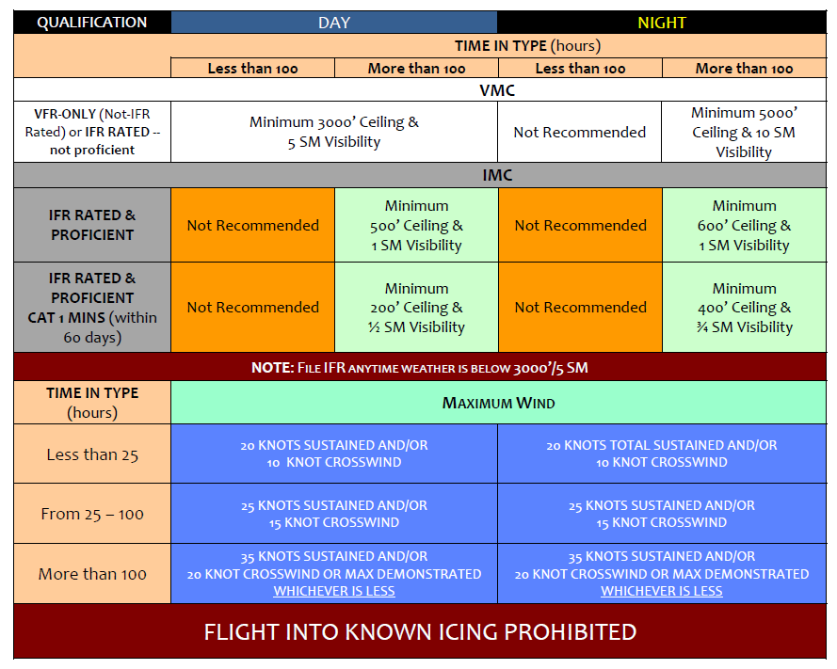

3.0 Instructional Methods

3.1 Recommended sequence of training sessions
The purpose of the recommended sequence of scenario-based training outlined in the subsequent sections is to establish a baseline of safe operations and then build more complex tasks upon the baseline.

3.2 Training Session – transition (Initial) Training
Lesson G1 – Ground (approximately 4.0 hours)

Text Reference

- Veloce ANG Training Manual

- Airplane Flight Manual

- FAR/AIM

- Airplane Flying Handbook (FAA‐H‐8083‐3, as amended)

- The Aviation Instructor’s Handbook (FAA‐H‐8083‐9, as amended)

- Certification and Operation of Amateur‐Built Aircraft AC 20‐27, as amended

- Aerodynamics For Naval Aviators (NAVIAR 00‐80T‐80)

Lesson Objectives

This is an opportunity to discuss, examine, and learn about the systems in your Veloce ANG. You will complete the lesson with a detailed understanding of all systems and also the checklist you intend to use for flight.

Training Elements

Training Program | Normal Procedures | Emergency Procedures/ Flight Safety | High-Performance Systems (if installed)
- FITS & SBT  - ADM, Risk Mgmt, SRM  - Systems  - Airframe Description  - Fuel  - Electrical  - Flight Controls  - Landing Gear  - Flaps  - Speed Brakes  - Hydraulics  - Wheel & Brakes  - Avionics  - Pitot Static  - Propeller  - Engine  - Pressurization & Air Conditioning (if installed) | - Checklist Usage  - Preflight  - Taxi  - Before Takeoff  - Takeoff  - Climb  - Cruise  - Descent  - Before Landing  - After Landing  - Chocks | - Engine Failure/ Forced Landings  - Fires  - Icing  - T/O & Landing EP’s  - Brake Failure  - Electrical  - Single-Pilot Resource Management  - Aeronautical Decision Making  - Risk Management | - Autopilot Operation  - Air Conditioning

Completion Standards

Demonstrate fundamental understanding of the training program, aircraft systems and operation, normal and emergency procedures, high performance systems, and SRM concepts including ADM and RM.
Note: The asterisk (*) indicates the desired pilot performance level
Elements | Grade
Elements | NA | NO | E* | D | MD | Pr | P
Training Program
Aircraft Systems
Normal Procedures
Emergency Procedures
Single Pilot Resource Management
Elements | Grade
Elements | E* | P | MD | NO
Automation/Avionics Management
Radio Communication
Hazard & Risk Analysis
Situational Awareness
Task Management
ADM
Checklist Use
Performance & Limitations

Lesson F1 – Flight (approximately 1.5‐ 2.0 Hours)

Reference

- Veloce ANG Flight Training Manual

- Airplane Flight Manual

- FAR/AIM

- Airplane Flying Handbook (FAA‐H‐8083‐3, as amended)

Lesson Objectives

The student pilot will observe and practice normal procedures in the Veloce ANG. The instructor will start, taxi, takeoff, and fly to the airspace as a demonstration before transferring aircraft control to the student once in the practice area. The student will run the checklist to keep them engaged in the flow of normal procedures. This is the instructor’s opportunity to describe Veloce ANG specific control inputs (starting with maximum right rudder deflection on takeoff) and systems to manage (like cylinder head temperatures on departure), then demonstrate the maneuvers (like noticing the extreme pitch sensitivity at cruise speeds) before transferring control.

Training Elements
- Single‐pilot Resource Management  - Aeronautical Decision Making  - Risk Management  - Checklist Use  - Operation of Airplane System  - Determining Performance & Limitations  - Emergency Procedures  - Ground Operations  - Engine Starting and warm-up  - Taxiing: Normal & Crosswind  - Normal Takeoff  - Emergency Procedures | - Climb  - Engine Operations/Monitoring/Cooling  - Steep Turns  - Slow Flight  - Straight and Level Turns  - Descents Straight and Turning  - Straight & Turning Stall Recognition/Recovery  - Traffic Pattern Procedures  - Normal Landing  - After Landing Procedures  - Stall Recognition

Scenario

After a long break in flying you need to go re-gain proficiency in your Veloce ANG. You choose a forgiving day and focus on basic aircraft handling.

Completion Standards

At the completion of this lesson the PT can perform the listed ground & flight operations with a minimum of instructor assistance. The PT will demonstrate knowledge of the power, attitude, and configuration (PAC) necessary to perform the listed maneuvers and procedures while maintaining altitude within the 200 feet, heading within 15 degrees and airspeed within 10 knots. The PT will learn how to manage the aircraft using sound ADM skills.

Single Pilot Resource Management
Elements | Desired Outcome
Elements | NA | NO | E | D | MD | Pr* | P | NG
Automation/Avionics Management
Radio Communication
Hazard & Risk Analysis
Situational Awareness
Task Management
ADM
Checklist Use
Performance & Limitations
Pre-Takeoff
Elements | Desired Outcome
Elements | NA | NO | E | D | MD | Pr* | P | NG
Preflight
Start
Before Taxi
Taxi
Before Takeoff
Checklist Use
Takeoff & Climb
Elements | Desired Outcome
Elements | NA | NO | E | D | MD | Pr* | P | NG
Normal/Crosswind Takeoff
Climb
Checklist Use
Cruise
Elements | Desired Outcome
Elements | NA | NO | E | D | MD | Pr* | P | NG
Initial Cruise
Enroute Cruise
Checklist Use
Slow-flight Maneuvers
Stall Recognition & Recovery
Steep Turns
Autopilot Stall Recognition & Recovery

Descent & Landing
Elements | Desired Outcome
Elements | NA | NO | E | D | MD | Pr* | P | NG
Descent & Arrival Procedures
Traffic Pattern
Normal/Crosswind Landing
No-flap Landing
Power-off Landing
Go Around
After Landing
Shutdown
Checklist Use
Post Flight
Elements | Desired Outcome
Elements | NA | NO | E | D | MD | Pr | P* | NG
Post-flight Critique & Discussion

Lesson G2 – Ground (approximately 2.0‐ 2.5 hours)

Reference Text

- Airplane Flight Manual

- Veloce ANG Training Syllabus

- Instrument Flying Handbook (FAA‐H‐8083‐15, as amended)

Lesson Objective

The PT will gain a fundamental understanding of the flight and engine instruments with emphasis on their use and limitations. The instructor will enhance the PT’s understanding of the practical use of advanced avionics, the practical application of aircraft performance, weight and balance computation and aircraft limitations. Additionally, the instructor will familiarize the PT with experimental/amateur‐ built aircraft issues with emphasis on the value and necessity of proper aircraft inspections.

Training Elements

Experimental/Amateur-Built AC | Aircraft Performance | Advanced Avionics
- Condition Inspection  - Repairman Certificate  - Maintenance Issues  - Test Flights  - Aircraft Inspections | - Weight and Balance  - Performance Factors  - Performance Charts  - Aircraft Limitations  - Vn Diagram | - GPS: Understanding & Use  - EFIS, AHARS & ADHARS  - Autopilot Use

Completion Standards

The PT demonstrates a working knowledge of aircraft avionics, instruments, systems and their limitations. The PT demonstrates an understanding of weight and balance calculations, aircraft limitations and performance. Additionally, the PT will demonstrate understanding of experimental/amateur‐built aircraft issues.

Elements | Desired Outcome
Elements | E* | P | MD | NO
Advanced Avionics
Systems
Instruments
Performance & Limitations
Weight & Balance
Experimental/Amateur-built Aircraft issues

Lesson F2—Flight (approximately 1.5‐ 2.0 hours)

Text Reference

- Veloce ANG Training Manual

- Airplane Flight Manual

- Airplane Flying Handbook (FAA‐H‐8083‐3, as amended)

Lesson Objectives

During this lesson the student will build on normal procedures and practice emergency procedures. Some students will be ready to move on to instrument flying after this lesson, but most of us will require additional practice. The Airman Certification Standards for private pilots will be used to determine competency.

Additionally, the PT will learn the power, attitude, and configurations required for the performance of the listed maneuvers and procedures. The PT will demonstrate how to conduct the necessary preflight activities. The flight will originate at a local field and proceed via day VMC, cross‐country flight to a nearby non‐towered airport (approximately 50‐80 nm / 30‐45 minutes leg length). The PT will complete all start, taxi, takeoff and departure, cruise, arrival and landing checklists as well as utilize advanced GPS navigation skills. The instructor will review practical use of EFIS (if installed) and/or autopilot (if installed). The instrument‐ rated PT will complete an instrument approach and full‐stop landing at destination #1. The non‐ instrument‐rated PT will complete a VFR arrival to a full‐stop landing. The PT will depart destination #1 and proceed to destination #2 using the above procedures. Repeat to point of origin.

Training Elements
- Single-pilot Resource Management  - Risk Management  - Systems Operation  - Determining Performance & Limitations  - Performance Maneuvers  - Ground Operations  - Engine Start & Warm-up  - Taxiing: Normal and Crosswind  - Takeoff  - Climb, Vx, Vy  - Engine Operation/Monitoring/Cooling  - Oil Pressure/Temp Out of Limits  - Cruise Climb  - EFIS/Autopilot Operation | - Cruise  - Alternator Failure  - Total Electrical Failure  - Landing Gear Malfunctions/Emergency Gear Extension  - Descent & Descent Planning  - Approach (instrument-rated pilots)  - Turbulent air penetration (Va)  - After Landing Procedures  - Normal Landings  - No-Flap Takeoff/Landing  - Go Around/Rejected Landing  - Rejected Takeoff  - Emergency 180 turn

Scenario

As the proud owner and operator of a high performing aircraft you will maintain higher levels of proficiency than your peers in more forgiving aircraft. With higher proficiency your will maintain a higher safety margin. This is your opportunity to practice in a controlled environment.

Completion Standard
At the completion of this lesson, the PT can perform the listed ground operations with a minimum of instructor assistance. The PT will demonstrate a knowledge of the PAC necessary to perform the listed maneuvers and procedures while maintaining altitude within the 200 feet, heading within 15 degrees, and airspeed within 10 knots.

Note: The asterisk (*) indicates the desired pilot performance level
Single Pilot Resource Management
Elements | Desired Outcome
Elements | NA | NO | E | D | MD | Pr* | P | NG
Automation/Avionics Management
Radio Communication
Hazard & Risk Analysis
Situational Awareness
Task Management
ADM
Checklist Use
Performance & Limitations
Automation/Avionics Management
Pre-Takeoff
Elements | Desired Outcome
Elements | NA | NO | E | D | MD | Pr | P* | NG
Preflight
Start
Before Taxi
Taxi
Before Takeoff
Checklist Use
Takeoff & Climb
Elements | Desired Outcome
Elements | NA | NO | E | D | MD | Pr | P* | NG
Normal/Crosswind Takeoff
Climb
Checklist Use
Cruise
Elements | Desired Outcome
Elements | NA | NO | E | D | MD | Pr | P* | NG
Initial Cruise
Enroute Cruise
Checklist Use
Engine Operations/Limitations
Emergency Procedures
Emergency Landing
EFIS/Autopilot Operations
Descent & Landing
Elements | Desired Outcome
Elements | NA | NO | E | D | MD | Pr | P* | NG
Descent & Arrival Procedures
Traffic Pattern
Normal/Crosswind Landing
Power-off Landing
Go Around
After Landing
Shutdown
Checklist Use
Post Flight
Elements | Grade
Elements | D | E | P* | MD
Post-flight Critique & Discussion

Lesson G3 – Ground approximately 1.5‐ 2.0 hours
Text Reference

- Airplane Flight Manual
- Veloce ANG Training Syllabus
- Veloce ANG Aircraft Accident Review
- Aeronautical Decision Making AC 60‐22, as amended
- FAR/AIM

Lesson Objectives
At the end of the lesson the PT will have gained a fundamental understanding of Veloce ANG accident statistics and the hazard of improper risk assessment. Additionally, the instructor will introduce single‐ pilot resource management concepts including practical risk management and aeronautical decision making.

Training Elements

Accident Statistics | Single-pilot Resource Management
- Weather (Thunderstorms, icing, IMC)  - Controlled Flight into Terrain (CFIT)  - Loss of Control  - Maneuvering Flight  - Time in Type  - Airworthiness | - Aeronautical Decision Making  - Risk Management
Completion Standards
The PT will demonstrate knowledge of the Veloce ANG accident history and causes, and single‐pilot resource management including aeronautical decision making and risk management strategies.
Elements | Desired Outcome
Elements | E* | P | MD | NO
Veloce ANG Accidents Statistics Review
Weather
CFIT
Loss of Control
Maneuvering Flight
Time in Type
Airworthiness
Single-pilot Resource Management
Aeronautical Decision Making
Risk Management
Lesson F3 – Flight (approximately 1.5 ‐2.0 hours)

Text Reference
- Veloce ANG Training Manual
- Airplane Flight Manual
- Airplane Flying Handbook (FAA‐H‐8083‐3, as amended)

Lesson Objective
The PT will review VFR maneuvers and normal procedures in the aircraft. The lesson will introduce and practice Veloce ANG emergency procedures. The flight will originate at a local field proceeding via day VMC, cross‐country flight to a nearby airport (approximately 50‐ 80 nm away). The PT will complete all start, taxi, takeoff and departure, cruise, arrival and landing checklists as well as utilize advanced GPS navigation skills including complex flight plan routing, departure and arrival procedures. EFIS skills will be reviewed (if equipped). Autopilot functions will be practiced (if equipped). A simulated en route emergency will require diversion. The instrument‐rated PT will make an approach and full stop landing at destination #1. The non instrument rated pilot will make a VFR arrival and landing. The PT will depart destination #1 and proceed to destination #2 using the above procedures. A second enroute emergency will develop requiring a demonstration of degraded aircraft systems operation. Repeat to point of origin.

Training Elements

SRM | Operations | Emergency Procedures | Arrival Procedures
- Risk Management  - Aeronautical Decision Making | - Autopilot Use  - Normal/Crosswind Takeoff  - Normal/Crosswind Landing | - Loss of Cabin Pressure/Smoke in Cockpit  - Engine Failure – Takeoff  - Recovery from Unusual Attitudes  - Cabin/Wing Fires  - Engine Fire  - Propeller Governor Malfunction  - Engine Out Landing  - Vacuum Failure  - Autopilot Malfunctions | - Visual/Instrument Approaches  - Power & Speed Management  - Basic VFR Procedures  - Communication Procedures

Training Scenario
You are flying to a neighboring manufacturing facility to meet with the company – a potential customer for your patented tagnite metal coating process. But, you must first pick up a division manager from the company at a nearby airport. He will ride with you to the neighboring manufacturing facility. Once at the facility, the CEO will meet you at the airport. Obviously, you wish to impress your passenger and the CEO with your professionalism – both in the air, and on the ground.

Completion Standards
At the completion of this flight lesson the PT will demonstrate the skill commensurate with the certificate held while using sound judgment in operation of the aircraft. The PT will apply the appropriate PAC in accomplishing all flight maneuvers while maintaining altitude within 100 feet, airspeed within 10 knots and heading within 10 degrees. The PT should complete all emergency procedures with limited assistance from the instructor.
Note: The asterisk (*) indicates the desired pilot performance level
Single Pilot Resource Management
Elements | Desired Outcome
Elements | NA | NO | E | D | MD | Pr | P* | NG
Automation/Avionics Management
Radio Communication
Hazard & Risk Analysis
Situational Awareness
Task Management
ADM
Checklist Use
Performance & Limitations
Terrain/CFIT Awareness
Pre-Takeoff
Elements | Desired Outcome
Elements | NA | NO | E | D | MD | Pr | P* | NG
Preflight
Start
Before Taxi
Taxi
Before Takeoff
Checklist Use

Takeoff & Climb
Elements | Desired Outcome
Elements | NA | NO | E | D | MD | Pr | P* | NG
Normal/Crosswind Takeoff
Engine Failure after Takeoff
Climb
Checklist Use
Cruise
Elements | Desired Outcome
Elements | NA | NO | E | D | MD | Pr | P* | NG
Initial Cruise
Enroute Cruise
Checklist Use
Electrical/Landing Gear Malfunction
Pressurization Loss/Smoke in Cockpit
Engine Failure
Emergency Landing
EFIS/Autopilot Operations
Descent & Landing
Elements | Desired Outcome
Elements | NA | NO | E | D | MD | Pr | P* | NG
Descent & Arrival Procedures/Instrument Approach
Traffic Pattern
Normal/Crosswind Landing
Power-off Landing
Go Around
After Landing
Shutdown
Checklist Use
Post Flight
Elements | Grade
Elements | D | E | P* | MD
Post-flight Critique & Discussion

Lesson F3I – Flight (approximately 1.5 ‐2.0 hours)

Text Reference

- Veloce ANG Training Manual

- Airplane Flight Manual

- Airplane Flying Handbook (FAA‐H‐8083‐3, as amended)

- Instrument Flying Handbook (FAA‐H‐8083‐15, as amended)

- Instrument Procedures Handbook (FAA‐H‐8261‐1, as amended)

Lesson Objective

The instrument‐rated PT will review and practice the principles of attitude instrument flying and how to correlate the flight instruments to maintain precise aircraft control. The instrument‐rated PT will review and practice use of advanced avionics within complicated airspace/ATC environment. The instrument‐ rated PT will review and practice ILS, GPS (including LPV), VOR instrument approaches, holds and demonstrate radial tracking. The flight will originate at a local field and proceed via day IFR cross‐ country flight to a nearby non towered airport with an instrument approach (approximately 50‐80 nm away). The PT will complete all start, taxi, takeoff and departure, cruise arrival and landing checklists as well as utilize basic IFR GPS navigation skills. IFR EFIS skills will be emphasized (if equipped). Autopilot functions will be reviewed and practiced (if equipped). An instrument approach and full stop landing will be made at destination #1. The PT will depart destination #1 and proceed to destination #2 using the above procedures. Repeat to point of origin.

Training Elements
- Single-pilot Resource Management  - Risk Management  - Aeronautical Decision Making  - Instrument Preflight  - Departure Checklist  - Normal Takeoff into IMC  - Climbs  - Clearance Adherence  - Straight and Level  - EFIS/Autopilot usage  - Turns  - Electrical Failure | - Descents & Descent Planning  - Partial Panel  - Holding  - TAWS Escape Maneuver  - IMC Emergency Landing  - Precision Approach  - Non-Precision Approach  - GPS Approaches  - Missed Approach  - Circling Approach  - Advanced Avionics

Training Scenario

Your planned cross country crosses several areas of marginal VFR and IFR conditions. You develop a robust plan to safely manage the weather to include identifying areas of prevailing VMC, sensible divert options, and studying your intended approaches.

Completion Standards

The instrument‐rated PT will demonstrate an understanding of power, attitude and configuration control by reference to the flight and power instruments while maintaining altitude within 100 feet, airspeed within 10 knots, and heading within 5 degrees.
Note: The asterisk (*) indicates the desired pilot performance level
Single Pilot Resource Management
Elements | Desired Outcome
Elements | NA | NO | E | D | MD | Pr | P* | NG
Automation/Avionics Management
Radio Communication
Hazard & Risk Analysis
Situational Awareness
Task Management
ADM
Checklist Use
Performance & Limitations
Terrain/CFIT Awareness
Pre-Takeoff
Elements | Desired Outcome
Elements | NA | NO | E | D | MD | Pr | P* | NG
Preflight
Start
Before Taxi
Taxi
Before Takeoff
Checklist Use
Takeoff & Climb
Elements | Desired Outcome
Elements | NA | NO | E | D | MD | Pr | P* | NG
Normal/Crosswind Takeoff
Engine Failure after Takeoff
Climb
Checklist Use

Cruise
Elements | Desired Outcome
Elements | NA | NO | E | D | MD | Pr | P* | NG
Initial Cruise
Enroute Cruise
Checklist Use
Electrical/Landing Gear Malfunction
Pressurization Loss/Smoke in Cockpit
Engine Failure
Emergency Landing
EFIS/Autopilot Operations
Descent & Landing
Elements | Desired Outcome
Elements | NA | NO | E | D | MD | Pr | P* | NG
Descent & Arrival Procedures/Instrument Approach
Traffic Pattern
Normal/Crosswind Landing
Power-off Landing
Go Around
After Landing
Shutdown
Checklist Use
Post Flight
Elements | Grade
Elements | D | E | P* | MD
Post-flight Critique & Discussion

Lesson F4I – Flight (approximately 1.5 ‐2.0 hours)

Text Reference
- Veloce ANG Training Manual
- Airplane Flight Manual
- Airplane Flying Handbook (FAA‐H‐8083‐3, as amended)
- Instrument Flying Handbook (FAA‐H‐8083‐15, as amended)
- Instrument Procedures Handbook (FAA‐H‐8261‐1, as amended)

Note: Non‐instrument‐rated PTs will complete lesson F4V (see page 31) instead of F4I.

Lesson Objective
The instrument‐rated PT will review and practice the principles of attitude instrument flying and how to correlate the flight instruments to maintain precise aircraft control. The instrument‐rated PT will review and practice use of advanced avionics within complicated airspace/ATC environment. The instrument‐ rated PT will review and practice ILS, GPS (including LPV), VOR instrument approaches, holds and demonstrate radial tracking. The flight will originate at a local field and proceed via day IFR cross‐ country flight to a nearby non towered airport with an instrument approach (approximately 50‐80 nm away). The PT will complete all start, taxi, takeoff and departure, cruise arrival and landing checklists as well as utilize basic IFR GPS navigation skills. IFR EFIS skills will be emphasized (if equipped). Autopilot functions will be reviewed and practiced (if equipped). An instrument approach and full stop landing will be made at destination #1. The PT will depart destination #1 and proceed to destination #2 using the above procedures. Repeat to point of origin.

Training Elements

- Single-pilot Resource Management  - Risk Management  - Aeronautical Decision Making  - Instrument Preflight  - Departure Checklist  - Normal Takeoff into IMC  - Climbs  - Clearance Adherence  - Straight and Level  - EFIS/Autopilot usage  - Turns  - Electrical Failure | - Descents & Descent Planning  - Partial Panel  - Holding  - TAWS Escape Maneuver  - IMC Emergency Landing  - Precision Approach  - Non-Precision Approach  - GPS Approaches  - Missed Approach  - Circling Approach  - Advanced Avionics

Training Scenario
It is homecoming weekend at Tippacanoe U., your alma mater and you and your two fraternity buddies are going to the big game. Kick off is at 1 pm so don’t be late. Even though the forecast calls for rain you are still a go since you have that coveted instrument rating. If you can’t get a hotel room you three are planning on returning after dinner at the old frat house.

Completion Standards
The instrument‐rated PT will demonstrate an understanding of power, attitude and configuration control by reference to the flight and power instruments while maintaining altitude within 100 feet, airspeed within 10 knots, and heading within 5 degrees.
Note: The asterisk (*) indicates the desired pilot performance level
Single Pilot Resource Management
Elements | Desired Outcome
Elements | NA | NO | E | D | MD | Pr | P* | NG
Automation/Avionics Management
Radio Communication
Hazard & Risk Analysis
Situational Awareness
Task Management
ADM
Checklist Use
Performance & Limitations
Terrain/CFIT Awareness
Pre-Takeoff
Elements | Desired Outcome
Elements | NA | NO | E | D | MD | Pr | P* | NG
Preflight
Start
Before Taxi
Taxi
Before Takeoff
Checklist Use
Takeoff & Climb
Elements | Desired Outcome
Elements | NA | NO | E | D | MD | Pr | P* | NG
Normal/Crosswind Takeoff
Engine Failure after Takeoff
Climb
Checklist Use
Cruise
Elements | Desired Outcome
Elements | NA | NO | E | D | MD | Pr | P* | NG
Initial Cruise
Enroute Cruise
Checklist Use
Pilotage/Dead-Reckoning
VOR/GPS Navigation
Emergency (Electrical)
Inadvertent IMC Recovery
EFIS/Autopilot Operations
Descent & Landing
Elements | Desired Outcome
Elements | NA | NO | E | D | MD | Pr | P* | NG
Descent & Arrival Procedures/Instrument Approach
Traffic Pattern
Normal/Crosswind Landing
Power-off Landing
Go Around
After Landing
Shutdown
Checklist Use
Post Flight
Elements | Grade
Elements | D | E | P* | MD
Post-flight Critique & Discussion

Lesson F4V – Flight (approximately 1.5 ‐2.0 hours)

Text Reference
- Veloce ANG Training Manual
- Airplane Flight Manual
- Airplane Flying Handbook (FAA‐H‐8083‐3, as amended
- Aeronautical Information Manual )

Lesson Objective
The non‐instrument‐rated PT will review and practice the principles of flying and how to correlate the flight instruments to maintain precise aircraft control. The non‐instrument‐rated PT will review and practice use of advanced avionics within complicated airspace/ATC environment. The non‐instrument‐ rated PT will review and practice VFR cross‐country skills including pilotage, dead‐reckoning, VOR and GPS navigation. The flight will originate at a local field and proceed via day VFR cross‐country flight to a nearby non towered airport (approximately 50‐80 nm away). The PT will complete all start, taxi, takeoff and departure, cruise arrival and landing checklists as well as utilize basic VFR GPS navigation skills. VFR EFIS skills will be emphasized (if equipped). Autopilot functions will be reviewed and practiced (if equipped). A visual pattern entry and full stop landing will be made at destination #1. The PT will depart destination #1 and proceed to destination #2 using the above procedures. Repeat to point of origin.

Training Elements

- Single-pilot Resource Management  - Risk Management  - Aeronautical Decision Making  - Checklist  - Normal Takeoff  - Climbs  - Cruise | - EFIS/Autopilot Use  - VFR Navigation  - Electrical Failure  - Descents & Descent Planning  - Inadvertent IMC Recovery  - Advanced Avionics  - GSP Navigation  - VOR Navigation

Training Scenario
It is homecoming weekend at Tippacanoe U., your alma mater and you and your two fraternity buddies are going to the big game. Kick off is at 1 pm so don’t be late. Even thought e forecast calls for rain you are still a go. If you can’t get a hotel room you three are planning on returning after dinner at the old frat house.

Completion Standards
The non‐instrument‐rated PT will demonstrate an understanding of power, attitude and configuration control by reference to the flight and power instruments while maintaining altitude within 100 feet, airspeed within 10 knots, and heading within 5 degrees.
Note: The asterisk (*) indicates the desired pilot performance level
Single Pilot Resource Management
Elements | Desired Outcome
Elements | NA | NO | E | D | MD | Pr | P* | NG
Automation/Avionics Management
Radio Communication
Hazard & Risk Analysis
Situational Awareness
Task Management
ADM
Checklist Use
Performance & Limitations
Terrain/CFIT Awareness
Pre-Takeoff
Elements | Desired Outcome
Elements | NA | NO | E | D | MD | Pr | P* | NG
Preflight
Start
Before Taxi
Taxi
Before Takeoff
Checklist Use
Takeoff & Climb
Elements | Desired Outcome
Elements | NA | NO | E | D | MD | Pr | P* | NG
Normal/Crosswind Takeoff
Engine Failure after Takeoff
Climb
Checklist Use

Cruise
Elements | Desired Outcome
Elements | NA | NO | E | D | MD | Pr | P* | NG
Initial Cruise
Enroute Cruise
Checklist Use
Pilotage/Dead-Reckoning
VOR/GPS Navigation
Emergency (Electrical)
Inadvertent IMC Recovery
EFIS/Autopilot Operations
Descent & Landing
Elements | Desired Outcome
Elements | NA | NO | E | D | MD | Pr | P* | NG
Descent & Arrival Procedures
Traffic Pattern
Normal/Crosswind Landing
Power-off Landing
Go Around
After Landing
Shutdown
Checklist Use
Post Flight
Elements | Grade
Elements | D | E | P* | MD
Post-flight Critique & Discussion

Lesson F5I – Flight (approximately 1.5 ‐2.0 hours)

Text Reference
- Veloce ANG Training Manual
- Airplane Flight Manual
- Airplane Flying Handbook (FAA‐H‐8083‐3, as amended)
- Instrument Flying Handbook (FAA‐H‐8083‐15, as amended)
- Instrument Procedures Handbook (FAA‐H‐8261‐1, as amended)

Note: Non‐instrument‐rated PTs will complete lesson F5V (see page 39) instead of F5I.

Lesson Objective
The instrument‐rated PT will plan and execute an instrument cross‐country (100‐200 nm in distance) flight to an agreed upon destination above FL180 (if turbocharged and pressurized or O2 equipped). En route the PT will practice a loss of cabin pressurization (if equipped) and perform an emergency descent terminating in an approach to a missed and a hold followed by another approach. The PT will emphasize weather evaluation and risk management. The elements learned in the previous flights will be practiced as part of a FITS scenario planned and executed by the instrument‐rated PT.

Training Elements

- Weight & Balance  - TOLD Planning  - File Flight Plan  - Instrument Preflight  - Departure Procedure  - High-Altitude Enroute Navigation/Communication | - Fuel Calculation/Reserve Planning Diversion  - Arrival Procedure & Descent Planning  - Holding  - Precision or Non-precision Approach  - Loss of Pressurization/Emergency Descent  - Normal Takeoff & Landing

Training Scenario
You promised your spouse that you would take the family to the grandparents for the holidays. The weather outside is frightful.

Completion Standards
The instrument‐rated PT demonstrates skill commensurate with the certificate(s) held and sound judgment in operation of the aircraft while maintaining altitude within 100 feet, heading within 5 degrees and airspeed to within 5 knots. The PT performs all emergency procedures such that a successful outcome is never seriously in doubt. The PT will adhere to checklist use at all times. All instrument approaches are performed to instrument rating practical test standards. The PT will demonstrate a mastery of IFR single‐pilot proficiency.
Note: The asterisk (*) indicates the desired pilot performance level
Single Pilot Resource Management
Elements | Desired Outcome
Elements | NA | NO | E | D | MD | Pr | P* | NG
Automation/Avionics Management
Radio Communication
Hazard & Risk Analysis
Situational Awareness
Task Management
ADM
Checklist Use
Performance & Limitations
Terrain/CFIT Awareness
Pre-Takeoff
Elements | Desired Outcome
Elements | NA | NO | E | D | MD | Pr | P* | NG
Preflight
Start
Before Taxi
Taxi
Before Takeoff
Checklist Use
Takeoff & Climb
Elements | Desired Outcome
Elements | NA | NO | E | D | MD | Pr | P* | NG
Normal/Crosswind Takeoff
Engine Failure after Takeoff
Climb
Checklist Use

Cruise
Elements | Desired Outcome
Elements | NA | NO | E | D | MD | Pr | P* | NG
Initial Cruise
Enroute Cruise
Checklist Use
ATC Radio Communication
VOR/GPS Navigation
Emergency (Loss of Cabin Pressure)
EFIS/Autopilot Operations
Descent & Landing
Elements | Desired Outcome
Elements | NA | NO | E | D | MD | Pr | P* | NG
Descent & Arrival Procedures
Traffic Pattern
Normal/Crosswind Landing
Power-off Landing
Go Around
After Landing
Shutdown
Checklist Use
Post Flight
Elements | Grade
Elements | D | E | P* | MD
Post-flight Critique & Discussion

Lesson F5V – Flight (approximately 1.5 ‐2.0 hours)

Text Reference
- Veloce ANG Training Manual
- Airplane Flight Manual
- Airplane Flying Handbook (FAA‐H‐8083‐3, as amended)

Lesson Objective
The non‐instrument‐rated PT will plan and execute a 100‐200 nm VFR cross‐country flight to an agreed upon destination at 14,500‐17,500’ MSL (if O2 equipped and/or pressurized). Enroute the PT will practice a loss of cabin pressurization (if equipped) followed by an emergency descent. The PT will emphasize proper weather evaluation and risk management. The PT will practice elements learned on previous flights as part of a FITS scenario planned by the non‐instrument‐rated PT.

Training Elements

- Weight & Balance  - TOLD Planning  - File Flight Plan  - Instrument Preflight  - Departure Procedure  - High-Altitude Enroute Navigation/Communication | - Fuel Calculation/Reserve Planning Diversion  - Arrival Procedure & Descent Planning  - VFR Approach  - Precision or Non-precision Approach  - Loss of Pressurization/Emergency Descent  - Normal Takeoff & Landing
Training Scenario
You promised your family you would go to the grandparents for the holidays. Its not the best time of year for flying, but your spouse really enjoys time with the family. Will all those presents fit in the baggage area?

Completion Standards
The non‐instrument‐rated PT demonstrates skill commensurate with the certificate(s) held and sound judgment in operation of the aircraft while maintaining altitude within 100 feet, heading within 5 degrees and airspeed within 5 knots. The PT performs emergency procedures such that the successful outcome is never seriously in doubt. The PT adheres to checklist use at all times while demonstrating a mastery of VFR single‐pilot proficiency in the Veloce ANG aircraft.

Note: The asterisk (*) indicates the desired pilot performance level
Single Pilot Resource Management
Elements | Desired Outcome
Elements | NA | NO | E | D | MD | Pr | P* | NG
Automation/Avionics Management
Radio Communication
Hazard & Risk Analysis
Situational Awareness
Task Management
ADM
Checklist Use
Performance & Limitations
Terrain/CFIT Awareness
Pre-Takeoff
Elements | Desired Outcome
Elements | NA | NO | E | D | MD | Pr | P* | NG
Preflight
Start
Before Taxi
Taxi
Before Takeoff
Checklist Use
Takeoff & Climb
Elements | Desired Outcome
Elements | NA | NO | E | D | MD | Pr | P* | NG
Normal/Crosswind Takeoff
Climb
Checklist Use
Cruise
Elements | Desired Outcome
Elements | NA | NO | E | D | MD | Pr | P* | NG
Initial Cruise
Enroute Cruise
Checklist Use
ATC Radio Communication
VOR/GPS Navigation
Emergency (Loss of Cabin Pressure)
EFIS/Autopilot Operations

Descent & Landing
Elements | Desired Outcome
Elements | NA | NO | E | D | MD | Pr | P* | NG
Descent & Arrival Procedures
Traffic Pattern
Normal/Crosswind Landing
Power-off Landing
Go Around
After Landing
Shutdown
Checklist Use
Post Flight
Elements | Grade
Elements | D | E | P* | MD
Post-flight Critique & Discussion

Lesson F6I – Flight (approximately 1.5 ‐2.0 hours)

Text Reference
- Veloce ANG Training Manual
- Airplane Flight Manual
- Airplane Flying Handbook (FAA‐H‐8083‐3, as amended)
- Instrument Flying Handbook (FAA‐H‐8083‐15, as amended)
- Instrument Procedures Handbook (FAA‐H‐8261‐1, as amended)

Note: Non‐instrument‐rated PTs will complete lesson F6V (see page 47) instead of F6I.

Lesson Objective
The instrument‐rated PT will plan and execute a return instrument cross‐country flight to airport of origin for flight F5I. Enroute the PT will practice selected emergency procedures.

Training Elements

- Weight & Balance  - Flight & Weather Planning  - TOLD Planning  - File Flight Plan  - Instrument Preflight  - Departure Procedure  - Enroute Navigation/Communication | - Fuel Calculation/Reserve Planning Diversion  - Arrival Procedure & Descent Planning  - Holding  - Precision or Non-precision Approach (GPS, VOR)  - Selected Emergency  - Normal Takeoff & Landing

Training Scenario
You just finished building the aircraft and really want to journey to Oshkosh for Airventure. The trip is long but the reward is the admiration your friends and fellow Veloce ANG pilots will show when they see this beauty on the line. You are hoping the judges agree.

Completion Standards
The instrument‐rated PT demonstrates skill commensurate with the certificate(s) held and sound judgment in operation of the aircraft while maintaining altitude within 100 feet, heading within 5 degrees and airspeed within 5 knots. The PT performs all emergency procedures such that the successful outcome is never seriously in doubt. The PT adheres to checklist use at all times. Instrument approaches are performed to instrument rating standards while the PT demonstrates a mastery of IFR single‐pilot proficiency.
Note: The asterisk (*) indicates the desired pilot performance level
Single Pilot Resource Management
Elements | Desired Outcome
Elements | NA | NO | E | D | MD | Pr | P* | NG
Automation/Avionics Management
Radio Communication
Hazard & Risk Analysis
Situational Awareness
Task Management
ADM
Checklist Use
Performance & Limitations
Terrain/CFIT Awareness
Pre-Takeoff
Elements | Desired Outcome
Elements | NA | NO | E | D | MD | Pr | P* | NG
Instrument Preflight
Start
Before Taxi
Taxi
Before Takeoff
Checklist Use
Takeoff & Climb
Elements | Desired Outcome
Elements | NA | NO | E | D | MD | Pr | P* | NG
Normal/Crosswind Takeoff
Instrument Takeoff/Departure Procedures
Climb
Checklist Use
Cruise
Elements | Desired Outcome
Elements | NA | NO | E | D | MD | Pr | P* | NG
Initial Cruise
Enroute Cruise
Checklist Use
ATC Radio Communication
GPS Navigation
AHRS Failure
EFIS/Autopilot Operations
Descent & Landing
Elements | Desired Outcome
Elements | NA | NO | E | D | MD | Pr | P* | NG
Descent & Arrival (STAR) Procedures
Instrument Approach
Traffic Pattern
Normal/Crosswind Landing
After Landing
Shutdown
Checklist Use
Post Flight
Elements | Grade
Elements | D | E | P* | MD
Post-flight Critique & Discussion

Lesson F6V – Flight (approximately 1.5 ‐2.0 hours)

Text Reference
- Veloce ANG Training Manual
- Airplane Flight Manual
- Airplane Flying Handbook (FAA‐H‐8083‐3, as amended)

Lesson Objective
The non‐instrument‐rated PT will plan and execute a VFR cross‐country flight. The PT will practice selected emergency procedures en route. The PT will practice elements learned from all previous flights as part of a FITS scenario planned and executed by the PT.

Training Elements

- Weight & Balance  - Flight & Weather Planning  - TOLD Planning  - File Flight Plan  - Preflight  - Departure Procedure | - Enroute Navigation/Communication  - Fuel Calculation/Reserve Planning Diversion  - Arrival & Descent Planning  - VFR Approach  - Selected Emergency  - Normal Takeoff & Landing

Training Scenario
You just finished building the aircraft and really want to journey to Oshkosh for Airventure. The trip is long but the reward is the admiration your friends and fellow Veloce ANG pilots will show when they see this beauty on the line. You are hoping the judges agree.

Completion Standards
The non‐instrument‐rated PT demonstrates skill commensurate with the certificate(s) held and sound judgment in operation of the aircraft while maintaining altitude within 100 feet, heading within 5 degrees and airspeed within 5 knots. The PT performs emergency procedures such that the successful outcome is never seriously in doubt. The PT adheres to checklist use at all times while demonstrating a mastery of VFR single‐pilot proficiency in the Veloce ANG aircraft.

Note: The asterisk (*) indicates the desired pilot performance level
Single Pilot Resource Management
Elements | Desired Outcome
Elements | NA | NO | E | D | MD | Pr | P* | NG
Automation/Avionics Management
Radio Communication
Hazard & Risk Analysis
Situational Awareness
Task Management
ADM
Checklist Use
Performance & Limitations/TOLD
Terrain/CFIT Awareness
Pre-Takeoff
Elements | Desired Outcome
Elements | NA | NO | E | D | MD | Pr | P* | NG
Preflight
Start
Before Taxi
Taxi
Before Takeoff
Checklist Use
Takeoff & Climb
Elements | Desired Outcome
Elements | NA | NO | E | D | MD | Pr | P* | NG
Normal/Crosswind Takeoff
Climb
Checklist Use
Cruise
Elements | Desired Outcome
Elements | NA | NO | E | D | MD | Pr | P* | NG
Initial Cruise
Enroute Cruise
Checklist Use
ATC Radio Communication
GPS Navigation
Emergency (Alternator loss/Electrical)
EFIS/Autopilot Operations

Descent & Landing
Elements | Desired Outcome
Elements | NA | NO | E | D | MD | Pr | P* | NG
Descent & Arrival Procedures
Traffic Pattern
Normal/Crosswind Landing
After Landing
Shutdown
Checklist Use
Post Flight
Elements | Grade
Elements | D | E | P* | MD
Post-flight Critique & Discussion

3.3 ground and flight session outlines – Recurrent Training
Lesson RG1 – ground (approximately 4.0 hours)

Text Reference
- Veloce ANG Training Manual
- Airplane Flight Manual
- FAR/AIM
- Airplane Flying Handbook (FAA‐H‐8083‐3, as amended)
- Certification and Operation of Amateur‐Built Aircraft AC 20‐27E, as amended
- The Aviation Instructor’s Handbook (FAA‐H‐8083‐9, as amended)

Lesson Objectives
During this ground training session the PT and instructor will review sound aeronautical decision making, risk management and single pilot resource management. Further discussion will include emphasis on aircraft systems, weight & balance computation, situational awareness, performance issues, and the unique handling qualities of Veloce ANG aircraft as they pertain to operations and limitations unique to experimental amateur built aircraft. All discussion topics will include implications for both normal and emergency operations.

Training Elements

Systems | Normal Procedures | Emergency Procedures/ Flight Safety | High Performance Systems
- Airframe Description  - Fuel  - Electrical  - Flight Controls  - Landing Gear  - Flaps  - Speed Brakes  - Hydraulics  - Wheel & Brakes  - Avionics  - Pitot Static  - Propeller  - Engine | - Checklist Use  - Preflight  - Taxi  - Before Takeoff  - Takeoff  - Climb  - Cruise  - Descent  - Before Landing  - After Landing  - Chocks | - Engine Failure/ Forced Landings  - Fires  - Icing  - T/O & Landing EP’s  - Brake Failure  - Electrical  - Single-pilot Resource Management  - Aeronautical Decision Making  - Risk Management | - Autopilot Operation  - Air-Conditioning

Experimental/Amateur-Built AC | Aircraft Performance | Advanced Avionics
- Condition Inspection  - Repairman Certificate  - Maintenance Issues  - Test Flights  - Aircraft Inspections | - Weight and Balance  - Performance Factors  - Performance Charts  - Aircraft Limitations  - Vn Diagram | - GPS: Understanding & Use  - EFIS, AHARS & ADHARS  - Autopilot Use

Completion Standards
The PT will demonstrate a fundamental understanding of aircraft operation, systems, description and operation of the constant‐speed propeller, engine cooling, weight & balance and aircraft limitations and performance. Additionally, the PT will demonstrate understanding of experimental amateur built aircraft issues.
Note: The asterisk (*) indicates the desired pilot performance level
Elements | Grade
Elements | E* | P | MD | NO
Training Program
Aircraft Systems
Normal Procedures
Emergency Procedures
Weather
GPS
Performance
Experimental Amateur-built Aircraft
High Performance Systems
Single Pilot Resource Management
Elements | Grade
Elements | E* | P | MD | NO
Automation/Avionics Management
Radio Communication
Hazard & Risk Analysis
Situational Awareness
Task Management
ADM
Checklist Use
Performance & Limitations

Lesson RF1 – Flight (approximately 2.0- 2.5 hours)

Text Reference
- Veloce ANG Training Manual
- Airplane Flight Manual
- Airplane Flying Handbook (FAA‐H‐8083‐3, as amended)

Lesson Objectives
During the lesson the PT will enhance their understanding of the Veloce ANG through review of the power, attitude, and configuration (PAC) required to perform the listed maneuvers and procedures. The mission will originate at a local field and proceed via day VMC cross‐country flight to a nearby airport (approximately 50 nm away). The PT will complete all start, taxi, takeoff and departure, cruise, arrival and landing checklists as well as utilize advanced GPS navigation skills. EFIS and autopilot operation will be reviewed (if equipped). The PT will make a full‐stop landing at the first destination. The second leg will mirror the flight profile of the first leg with the PT accomplishing any maneuvers requiring further practice. Additionally, the instructor will introduce a simulated emergency situation requiring a diversion. The PT will review and accomplish emergency landing procedures at one or more of the destination airports during the mission. The instructor will use the return flight to the point of origin to further practice maneuvers or procedures requiring additional training.

raining Elements

- Operation of airplane systems  - Determining Performance and Limitations  - Performance Maneuvers  - Ground Operations  - Engine Start & Warm-up  - Taxiing: Normal & Crosswind  - Takeoff  - Climb – Vx,Vy  - Engine Operations/Monitoring/Cooling  - Cruise Climb  - Straight & Level Turns  - Steep Turns  - Slow Flight  - Straight & Turning Stall Recognition/Recovery  - Descents & Descent Planning  - After Landing Procedures  - Normal Landings  - Emergency Landing  - Flight at Slow Airspeeds (high AOA)  - Go Around Rejected landing | - Abnormal and Emergency Procedure Demo & Practice (selected)  - Full-Partial In-Flight Engine Failure  - Loss of Cabin Pressure  - Engine Failure after Takeoff  - Recovery from Unusual Attitudes  - Cabin/Wing Fires  - Engine Fire  - Landing Gear Malfunction/Emergency Gear Extension  - Oil Pressure/Temo Out of Limits  - Propeller Governor Malfunction  - Engine-Out Landing Procedures  - Alternator Failure  - Total Electrical Failure  - Vacuum Failure  - Autopilot Malfunctions  - No-Flap Take Off/Landing  - Rejected Takeoff  - Emergency 180 turn

Training Scenario
You have a friend who is also a pilot. He is considering the purchase of an airplane. The friend has less flight experience than you, so he asks you to conduct an airplane performance flight and give him a recommendation. In order to help your friend make the best decision you will really have to put the airplane through its paces – exploring some specific areas of flight performance in particular. The areas you have special interest in are: slow flight characteristics, stall recognition, and takeoff and landing performance. You get started when the current owner of the airplane allows you to take the airplane for a “test drive.”

NOTE: Due to the experimental, amateur‐built nature of the Veloce ANG, stall characteristics – and more importantly stall recovery techniques – have not been determined for each and every Veloce ANG. Therefore, at no time will the instructor or PT intentionally stall the aircraft!

Instructor Notes
Lesson RF1 is planned as a three‐leg cross‐country flight incorporating traditional maneuver‐based training demonstrating and practicing PTS maneuvers including slow flight, steep turns, stall recognition and takeoffs and landings. The Veloce ANG pilot should be given a thorough review of the aircraft takeoff and landing characteristics.

Completion Standards
The PT shall demonstrate knowledge and skill commensurate with the certificate(s) held, and sound judgment in operation of the aircraft. At a minimum, the PT should maintain heading within 5 degrees, altitude to within 100 feet, and airspeed to within 5 knots. The PT will perform all Emergency procedures such that the successful outcome is never seriously in doubt. The PT must use checklists at all times. The PT must demonstrate proficiency in single‐pilot operation of the aircraft and installed systems.
Note: The asterisk (*) indicates the desired pilot performance level
Single Pilot Resource Management
Elements | Desired Outcome
Elements | NA | NO | E | D | MD | Pr | P* | NG
Automation/Avionics Management
Radio Communication
Hazard & Risk Analysis
Situational Awareness
Task Management
ADM
Checklist Use
Performance & Limitations
Pre-Takeoff
Elements | Desired Outcome
Elements | NA | NO | E | D | MD | Pr | P* | NG
Preflight
Start
Before Taxi
Taxi
Before Takeoff
Checklist Use
Takeoff & Climb
Elements | Desired Outcome
Elements | NA | NO | E | D | MD | Pr | P* | NG
Normal/Crosswind Takeoff
Climb
Checklist Use

Cruise
Elements | Desired Outcome
Elements | NA | NO | E | D | MD | Pr | P* | NG
Initial Cruise
Enroute Cruise
Checklist Use
Slow Flight Maneuvers
Stall Recognition & Recovery
Autopilot Stall Recognition & Recovery
Steep Turns
Descent & Landing
Elements | Desired Outcome
Elements | NA | NO | E | D | MD | Pr | P* | NG
Descent & Arrival Procedures
Traffic Pattern
Normal/Crosswind Landing
Zero-Flap Landing
Power-Off Landing
Emergency Gear Extension
After Landing
Shutdown
Checklist Use
Post Flight
Elements | Grade
Elements | D | E | P* | MD
Post-flight Critique & Discussion

Lesson RFI2 – Flight (approximately 2.0- 2.5 hours)

Text Reference
- Veloce ANG Training Manual
- Airplane Flight Manual
- Airplane Flying Handbook (FAA‐H‐8083‐3, as amended)
- Instrument Flying Handbook (FAA‐H‐8083‐15, as amended)
- Instrument Procedures Handbook (FAA‐H‐8261‐1, as amended)

Lesson Objective

NOTE: This training flight is aimed specifically at the instrument‐rated PT. VFR‐only pilots will complete lesson RFV2 (described in the next section.

The PT will review and practice the principles of attitude instrument flying and the correlation of flight instruments to maintaining precise aircraft control during a three‐leg cross country flight. The PT will review and practice use of advanced avionics within the airspace/ATC environment. The PT will review and practice ILS, GPS and VOR instrument approaches, holds and demonstrate radial tracking. The flight will originate at a local field and proceed via day or night IFR cross‐country flight to a nearby airport (approximately 50‐80 nm away). The PT will complete all start, taxi, takeoff and departure, cruise, arrival and landing checklists, as well as utilize advanced GPS navigation skills. EFIS and autopilot operation will be reviewed (if installed). The PT will accomplish a full‐stop landing at the first destination. The second and third legs will mirror the flight profile of the first leg with the PT accomplishing any maneuvers requiring further practice.

Training Elements
- Instrument Preflight  - Normal Takeoff into IMC  - Climbs  - Straight & Level  - Turns (Level)  - Descents & Descent planning  - Steep Turns  - Standard Rate Turns  - Partial Panel  - Holding  - Emergency IMC Landing | - Constant Airspeed Descents  - Constant Rate Descents  - Constant Airspeed Climbs  - Constant Rate Climbs  - Precision Approach  - Non-Precision Approach  - GPS Approaches  - Missed Approach  - Circling Approach  - Advanced Avionics

Training Scenario
It is homecoming weekend at Tippacanoe U., your alma mater. You and two fraternity buddies are going to the big game. Kick off is at 1 pm so don’t be late. Even though the forecast calls for rain you are still a go since you have that coveted instrument rating. If you can’t get a hotel room you three are planning on returning after dinner at the old frat house.

Instructor Notes
Lesson RFI2 is a scenario‐based, three‐leg short cross‐country flown under simulated IMC conditions. The PT will program a GPS course to another airport allowing 20 to 30 minutes enroute. Following a normal takeoff and departure the PT should navigate to the destination at a median altitude. If installed, the PT should program and use the autopilot and GPS for all phases of flight including the climb and level off, autopilot/GPS‐coupled navigation and a GPS approach at the destination. The PT will execute a missed approach to a hold to prepare for another instrument approach of the instructor’s choosing. The second approach should terminate with a full‐stop landing. The second leg will mirror the flight profile of the first with the instructor adding a simulated TAWS warning on approach requiring the PT to perform an appropriate escape maneuver. The third leg (a return to the originating airport) will mirror the first two legs with the instructor adding an AHARS failure (if installed).

Completion Standards
The PT will demonstrate an understanding of PAC flight management and aircraft control by reference to the flight and power instruments. The PT should maintain altitude within 100 feet, airspeed within 10 knots, and heading within 5 degrees. The PT will perform all Emergency Procedures such that the successful outcome is never seriously in doubt. The PT must use checklists at all times. The PT must demonstrate proficiency in single‐pilot IFR operation of the aircraft and installed systems.
Note: The asterisk (*) indicates the desired pilot performance level
Single Pilot Resource Management
Elements | Desired Outcome
Elements | NA | NO | E | D | MD | Pr | P* | NG
Automation/Avionics Management
Radio Communication
Hazard & Risk Analysis
Situational Awareness
Task Management
ADM
Checklist Use
Performance & Limitations
Terrain/CFIT Awareness

Pre-Takeoff
Elements | Desired Outcome
Elements | NA | NO | E | D | MD | Pr | P* | NG
Instrument Preflight
Start
Before Taxi
Taxi
Before Takeoff
Checklist Use
Takeoff & Climb
Elements | Desired Outcome
Elements | NA | NO | E | D | MD | Pr | P* | NG
Normal/Crosswind Takeoff
Climb
Checklist Use
Cruise
Elements | Desired Outcome
Elements | NA | NO | E | D | MD | Pr | P* | NG
Initial Cruise
Enroute Cruise
Checklist Use
GPS Navigation
EFIS/Autopilot Operation
Partial Panel
Unusual Attitude Recovery
Descent & Landing
Elements | Desired Outcome
Elements | NA | NO | E | D | MD | Pr | P* | NG
Descent & Arrival Procedures
Approach
Traffic Pattern
Normal/Crosswind Landing
Go Around
After Landing
Shutdown
Checklist Use
Post Flight
Elements | Grade
Elements | D | E | P* | MD
Post-flight Critique & Discussion

Lesson RFV2 – Flight (approximately 2.0- 2.5 hours)

Text Reference
- Veloce ANG Training Manual
- Aircraft Flight Manual
- Airplane Flying Handbook (FAA‐H‐8083‐3, as amended)
- Instrument Flying Handbook (FAA‐H‐8083‐15, as amended)
- Instrument Procedures Handbook (FAA‐H‐8261‐1, as amended)

Lesson Objective

NOTE: This training flight is aimed specifically at the VFR PT.

The PT will review and practice the principles of VFR cross country flying and the correlation of flight instruments to maintaining precise aircraft control during a three‐leg cross country flight. The PT will review and practice use of advanced avionics within the airspace/ATC environment utilizing ATC flight following where available. The PT will review and practice visual, GPS and VOR navigation and demonstrate radial tracking. The flight will originate at a local field and proceed via day or night VFR cross‐country flight to a nearby airport (approximately 50‐80 nm away). The PT will complete all start, taxi, takeoff and departure, cruise, arrival and landing checklists, as well as utilize advanced GPS navigation skills. EFIS and autopilot operation will be performed (if installed). The PT will accomplish a full‐stop landing at the first destination. The second and third legs will mirror the flight profile of the first leg with the PT accomplishing any maneuvers requiring further practice.

Training elements
- Preflight  - Normal Takeoff  - Climbs  - Straight & Level  - Turns (Level)  - Descent & Descent Planning  - Steep Turns  - Emergency Landing | - Constant Airspeed Descents  - Constant Rate Descents  - Constant Airspeed Climbs  - Constant Rate Climbs  - Advanced Avionics  - VOR Navigation  - GPS Navigation

Training Scenario
It is homecoming weekend at Tippacanoe U., your alma mater. You and two fraternity buddies are going to the big game. Kick off is at 1 pm so don’t be late. Even though the forecast calls for rain, the weather is VFR, so you are still a go. If you can’t get a hotel room you three are planning on returning after dinner at the old frat house.

Instructor Notes
Lesson RFV2 is a scenario‐based, three‐leg short cross‐country flown under VMC conditions. The PT will program a GPS course to another airport allowing 20 to 30 minutes enroute. Following a normal takeoff and departure the PT should navigate to the destination at a median altitude. If installed, the PT shall program and use the autopilot and GPS for all phases of flight after takeoff including the climb and level off, autopilot/GPS‐coupled navigation and a VFR pattern entry at the destination. Abnormal and emergency procedures will be practiced including an electrical system malfunction. The second leg will mirror the flight profile of the first with the instructor adding a simulated TAWS warning on approach requiring the PT to perform an appropriate escape maneuver. The third leg (a return to the originating airport) will mirror the first two legs with the instructor adding an AHARS failure (if installed).

Completion Standards
The PT will demonstrate an understanding of PAC flight management and aircraft control by reference to the flight and power instruments. The PT should maintain altitude within 100 feet, airspeed within 10 knots, and heading within 5 degrees. The PT will perform all Emergency Procedures such that the successful outcome is never seriously in doubt. The PT must use checklists at all times. The PT must demonstrate proficiency in single‐pilot operation of the aircraft and installed
Note: The asterisk (*) indicates the desired pilot performance level

Single Pilot Resource Management
Elements | Desired Outcome
Elements | NA | NO | E | D | MD | Pr | P* | NG
Automation/Avionics Management
Radio Communication
Hazard & Risk Analysis
Situational Awareness
Task Management
ADM
Checklist Use
Performance & Limitations
Terrain/CFIT Awareness

Pre-Takeoff
Elements | Desired Outcome
Elements | NA | NO | E | D | MD | Pr | P* | NG
Preflight
Start
Before Taxi
Taxi
Before Takeoff
Checklist Use
Takeoff & Climb
Elements | Desired Outcome
Elements | NA | NO | E | D | MD | Pr | P* | NG
Normal/Crosswind Takeoff
Climb
Checklist Use
Cruise
Elements | Desired Outcome
Elements | NA | NO | E | D | MD | Pr | P* | NG
Initial Cruise
Enroute Cruise
Checklist Use
GPS Navigation
EFIS/Autopilot Operation
EFIS/PFD/AHARS Malfunction
Unusual Attitude Recovery

Descent & Landing
Elements | Desired Outcome
Elements | NA | NO | E | D | MD | Pr | P* | NG
Descent & Arrival Procedures
Selected Emergency
Traffic Pattern
Normal/Crosswind Landing
TAWS Escape Maneuver
Go Around
After Landing
Shutdown
Checklist Use
Post Flight
Elements | Grade
Elements | D | E | P* | MD
Post-flight Critique & Discussion
4.0 Training Resources

4.1 Course Administration
The Veloce ANG Training guides are produced and maintained by the Director of Training for the Veloce ANG Owners and Builders Organization (VOBO).

4.2 qualified instructors
The Veloce ANG Owners and Builders Organization maintains a current list of qualified and endorsed Veloce ANG instructors. These instructors offer Veloce ANG-specific Transition and Recurrent training and have agreed to use the FITS-accepted training materials.

5.0 supplemental information

Veloce ANG AIRCRAFT SYSTEMS

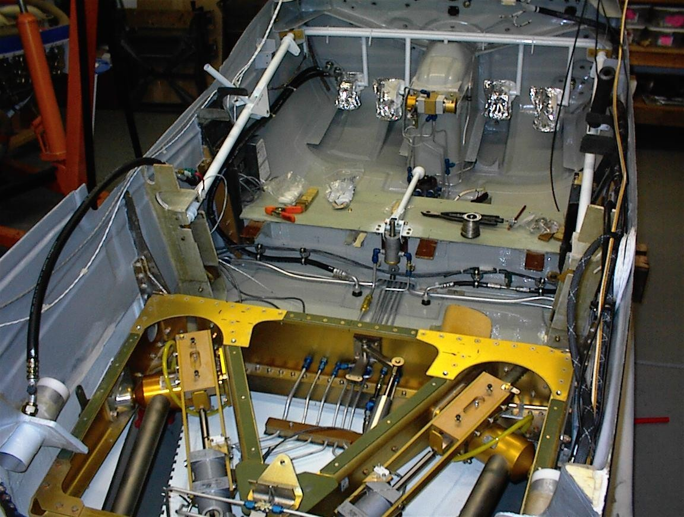
The Veloce ANG IV is a high performance, four-seat, amateur built aircraft, and it is normally powered by the Teledyne/Continental TSIO-550 or the IO-550. The selected engine will drive either a two, three, or four blade constant speed propeller. Common propellers used on the airplane are the Hartzell HC-H3YF- 1RF and the MTV-9. The aircraft features a composite airframe of predominately carbon fiber in an epoxy resin matrix. The wings have hydraulically actuated full slotted fowler flaps and mechanically actuated high aspect ratio ailerons. Speed brakes may be installed at approximately mid-span of the top of the wings. The elevator and rudder have centerline bearings. The elevator is push rod actuated; a stainless steel cable actuates the rudder. The tricycle retractable landing gear is hydraulically actuated. The nose gear is a self centering free swiveling unit and has an oleo strut for dampening. The main gear struts are made of tubular steel. The main wheel brakes have their own independent system and are hydraulically actuated.

TSIO-550 POWERPLANT

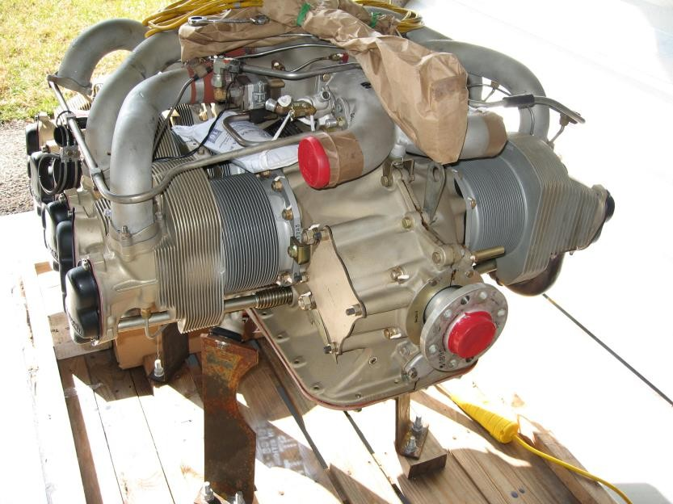

At takeoff power of 2700 rpm and 38(A,B) or 38.5 (E) in. Hg., the TSIO-550 develops 350 horsepower. The engine may be operated at maximum takeoff power in the climb to cruise altitude. Maximum recommended cruise power setting is 2500 rpm and 31.5 in. Hg., which yields 263 horsepower or 75% power. The engine is equipped with two Airesearch turbochargers and dual intercoolers. Overboost protection is provided by a pressure relief valve to limit compressor discharge pressure. The two magnetos are pressurized to accommodate high altitude operations. The engine is equipped with a TCM continuous fuel flow injection system. This system meters fuel flow in proportion to engine rpm., throttle angle, and throttle entrance pressure. Manual mixture control and idle cut-off are provided. A Dukes auxiliary boost pump is installed. The low- pressure position is used for suppression of vapor at altitude. The high-pressure pump position is used as a primer or as an emergency source for fuel pressure. A primer pump is also installed to assist in engine start. The engine is provided with a wet sump, high-pressure oil system of 12-quart capacity.

The IO-550 develops 300 horsepower at full throttle, 29.6 in. Hg., and 2700 rpm. A cruise climb setting of 2500 rpm and full throttle initially yields 240 horsepower, but power available will start decreasing after approximately 6,000 feet MSL.
The engine driven altitude compensating fuel pump will automatically lean engine mixture for the airplane’s pressure altitude, so manual leaning is not necessary until cruise altitude is reached. The manual mixture control also provides for idle cut-off. A Dukes auxiliary boost pump is installed. The low-pressure position is used for suppression of vapor at altitude. The high-pressure pump position is used as a primer or as an emergency source for fuel pressure. The engine oil system is the full pressure, wet sump type and it has a 12-quart capacity

PROPELLER
The engine drives a two, three, or four bladed constant speed propellers. A governor, controlled by mechanical linkage from the cockpit, maintains the selected rpm, regardless of varying airspeeds or flight loads. The governor controls rpm by regulating oil pressure to the propeller hub. Propeller high pitch (low rpm) is obtained by propeller governor boosted oil pressure working against the centrifugal twisting moment of the blades and a spring. Loss of oil pressure will cause the prop to go to high rpm and thus possible overspeed. The propeller should be cycled occasionally, especially during cold conditions, to maintain warm oil in the hub.

FLIGHT CONTROLS
The primary flight controls are the ailerons, rudder, and elevator. These control surfaces are operable from either front seat by interconnected side stick controls and rudder pedals. On the LIVP the controls run through the pressure bulkheads to the non-pressurized side of the cabin. A pressure compensator is used on older used to compensate for the effects of an expanding cabin.

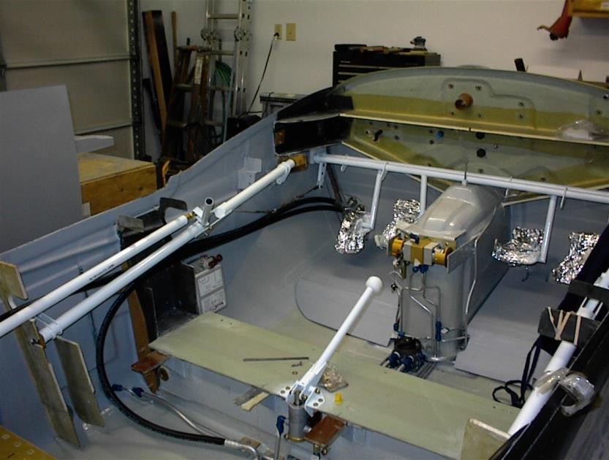

All primary flight controls use centerline hinging on bearings. The ailerons and
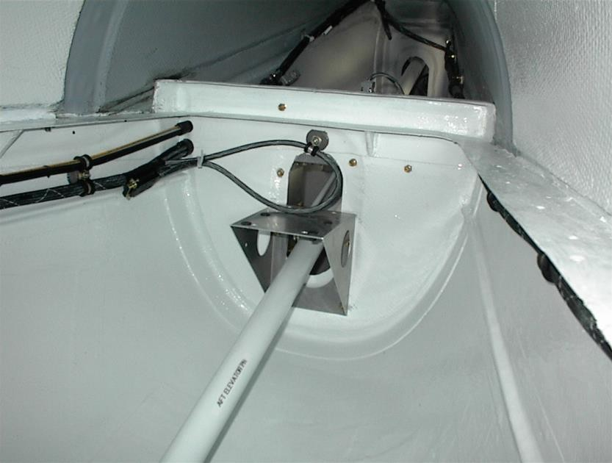

elevator is push rod actuated. Both side stick controls have positive grip handles and should have a radio transmit button mounted on them. Other switches may be mounted on the grips. The rudder pedals actuate the rudder with stainless steel cables. The wheel brakes are actuated by pressure on the top of the rudder pedals.
The secondary flight controls are the wing flaps and speed brakes.

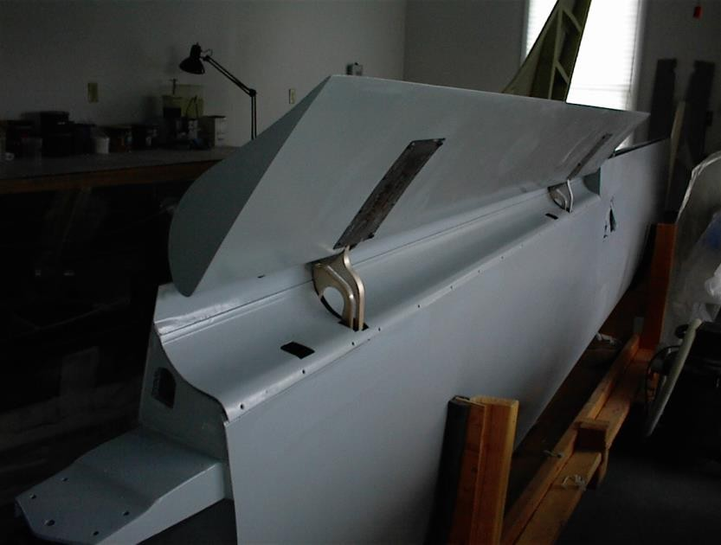
The hydraulically driven fowler flaps extend from aileron to fuselage on each wing.
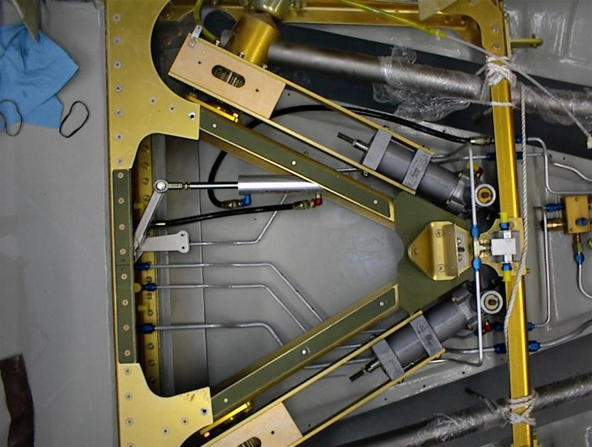
The flaps are operated by a flap valve mounted below the throttle quadrant and are selectable to any setting between zero and forty degrees. Electrically or manually operated speed brakes may be installed on the wings. Precise Flight speed brakes deployment will give the aircraft approximately a 1,300 fpm descent at a constant power setting and airspeed.

LANDING GEAR
The landing gear system is electrically controlled and hydraulically operated. The landing gear and flap control valves are located below the throttle quadrant and operate a rotating hydraulic valve.
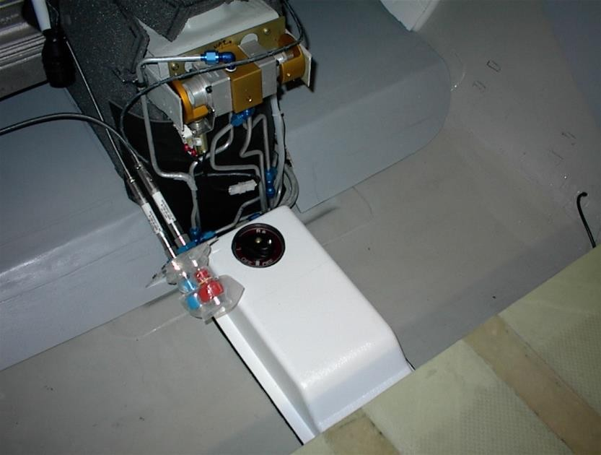
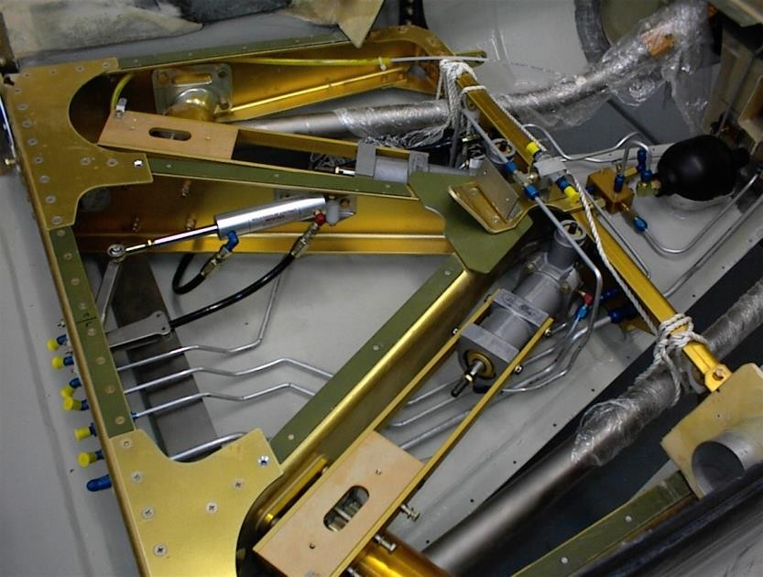

This hydraulic system operates at 1100 psi.

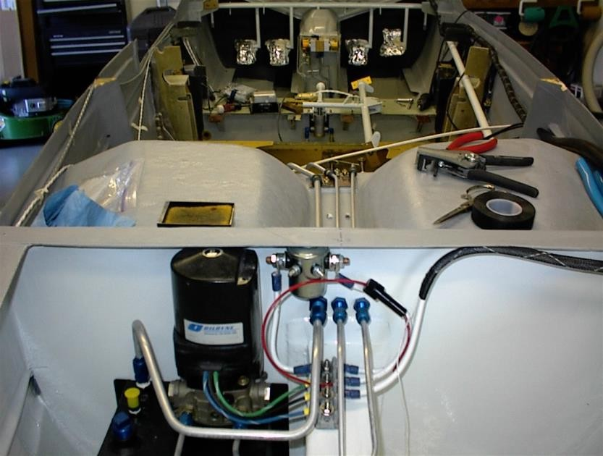
An airspeed switch mounted on the pitot tube line prevents gear retraction below 75 kts. For landing gear retract tests on jacks you must blow into the pitot tube to get enough “airspeed” to disengage the airspeed safety switch. A balloon will also do the trick. The main gear is retracted into the fuselage via full rack and pinion gears, and the nose gear also retracts aft.
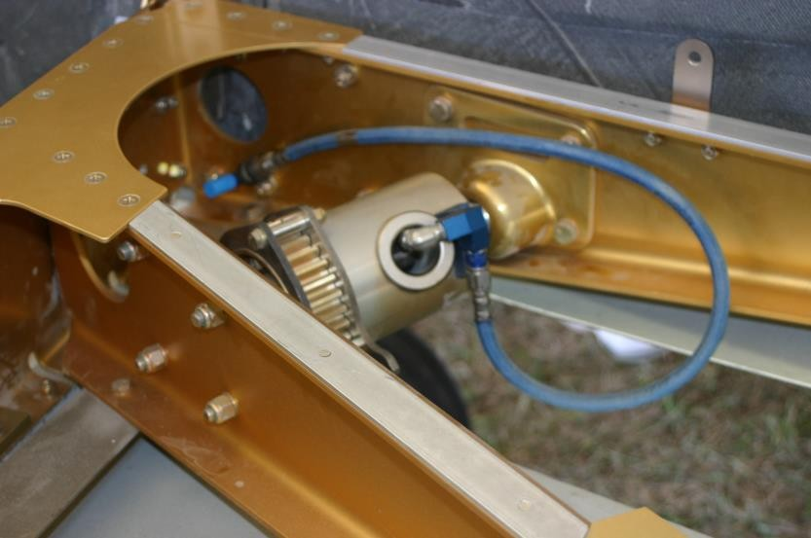

The mains and the nose gear are held up by hydraulic pressure. The mains have mechanical down locks in the hydraulic actuating cylinder and a 110 psi gas shock strut provides a positive down/lock for the nose gear. There is no “uplock “ on the mains. During condition inspection check operation of the mechanical downlock.

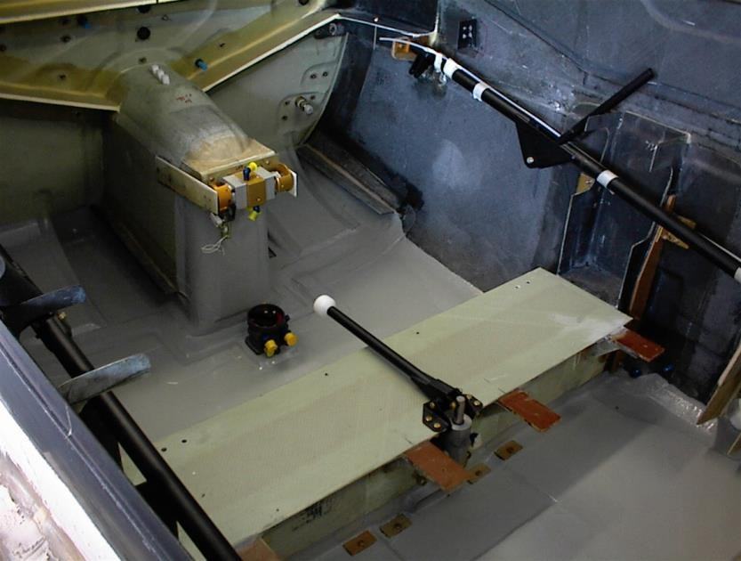

An emergency landing gear hand pump is located between the front seats. This hand pump has its own supply of hydraulic fluid in the secondary reservoir located within the primary hydraulic reservoir. The same extension hydraulic lines are used by both the normal and emergency systems. The main gear is made of tubular steel with 15 x 600 x 6 wheel and tires and hydraulically operated Cleveland disc brakes. The nose gear is a free swivel conventional air/oleo strut with internal viscous shimmy dampening. Any shimmy of the nose gear is cause for an immediate inspection of the nose strut. The nose gear has a 500 x 5 wheel and tire. On older LIV’s a tire guide strap centers the nose gear to insure full retraction. Differential braking is used for directional control on the ground until the rudder becomes effective. A two-position landing gear handle is located below the throttle quadrant. The landing gear position indicating system consists of three green lights that illuminate when all three gear are down and locked. Correct tire pressures are 60 psi for the mains and 50 psi for the nose tire if Goodyear or Condor tires are mounted, or 40 and 30 psi respectively if McCreary tires are mounted.

ELECTRICAL
In general, the airplane’s circuitry is dual – wire with ground return.
The battery, alternator, and the magneto/start witches are located on the left subpanel. The circuit breakers are generally located on the far right of the panel. The standard battery installation is one 12 or 24 -volt battery located just forward of the firewall on the right side. Some aircraft have dual alternators and dual battery installations.
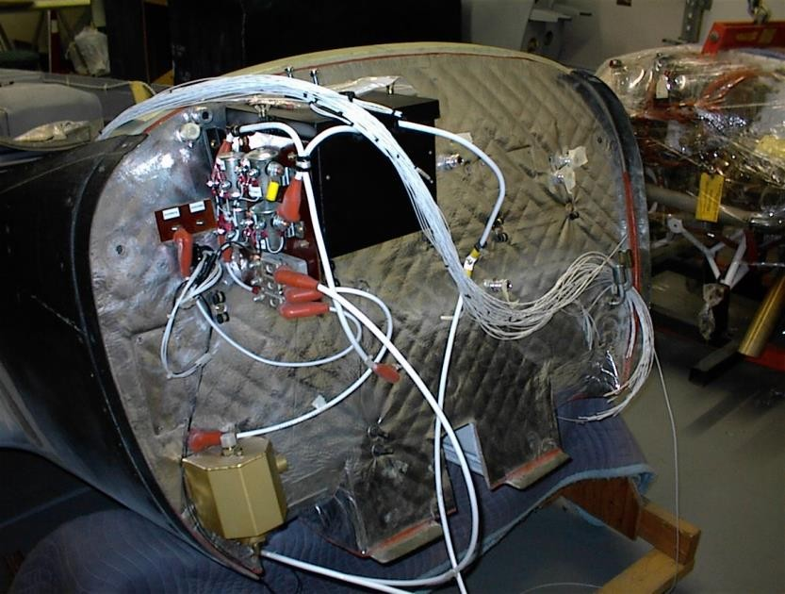

A 60 or 100 ampere gear driven alternator is mounted on the right front of the engine.
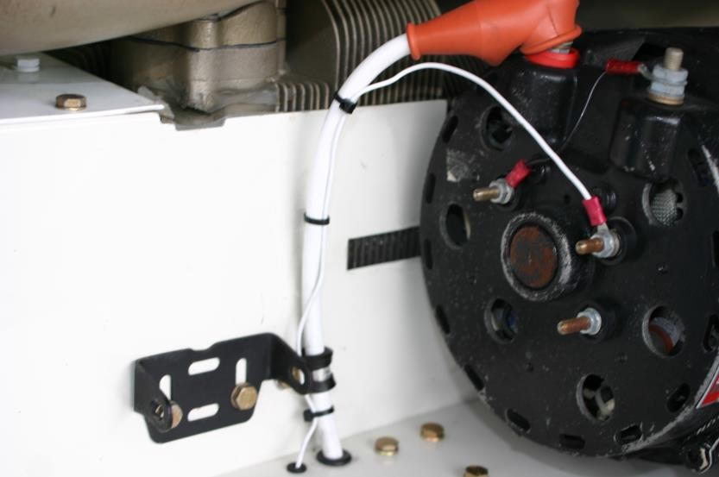

A transistorized voltage regulator adjusts alternator output to the required load, which may be either 14 or 28 volts. The engine starter is located on the engine accessory case (aft right side). To energize the starter circuit, hold the magneto start switch in the START position. There is a 30 second limit on starter operation. The radio master, pitot heat and internal and external light switches are also located on the left subpanel. An ammeter/ loadmeter generally should be installed.

PITOT STATIC/VACUUM
The aircraft will generally have one electrically heated pitot tube mounted on the left wing underside. The unheated static source may be on the pitot tube or mounted on the aft fuselage. Generally, a static drain is not installed. The alternate static source toggle switch (if installed) is located under the left subpanel and uses ambient cabin air as its source. A vacuum pump (if installed) is located on the engine accessory case. It delivers 4.5 – 5.4 in. Hg. for the vacuum operated gyroscopic flight instruments.

FUEL SYSTEM

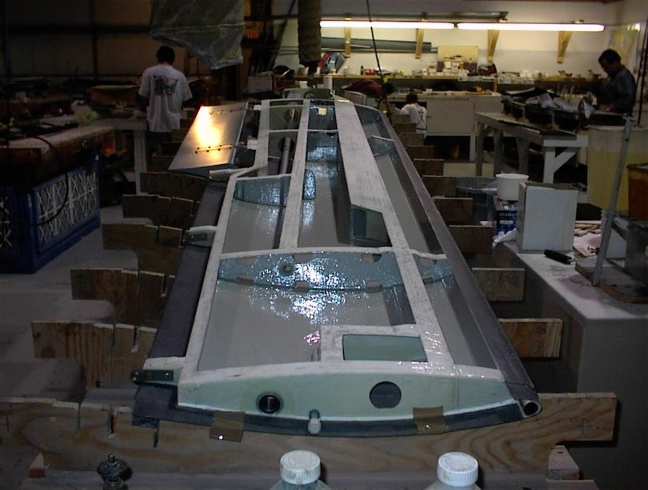

The aircraft has two wet wing fuel tanks. The fuel tanks vary in size from 80 gallons to 110 gallons and run from the inboard to outboard end of each wing. The tanks are vented to the outside atmosphere by ports on the bottom of the wingtip and each cell has flush type filler caps mounted above the cell. There are one or two low point drains on each wing. Fuel runs into a baffle tank on the inboard end of the cell. It has a one-way flapper valve that keeps fuel from running outboard in unbalanced flight. Generally, two gallons is unusable per wing.
The selector valve located on the floor below the throttle quadrant has a LEFT RIGHT and OFF position. Fuel will not flow if the pilot selects an intermediate position. The pilot must select the respective tank and switch tanks often in flight in order to maintain a balanced wing.

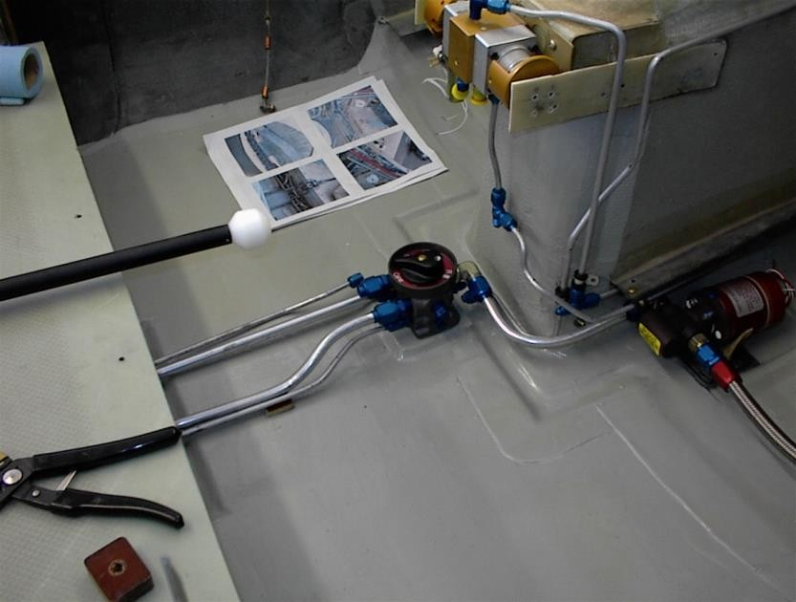

Fuel flows from the selector valve to an electric boost pump located on the floor or sidewall and then through the firewall to the fuel filter/ sump. The boost pump has an overboard drain should the pump diaphragm fail.
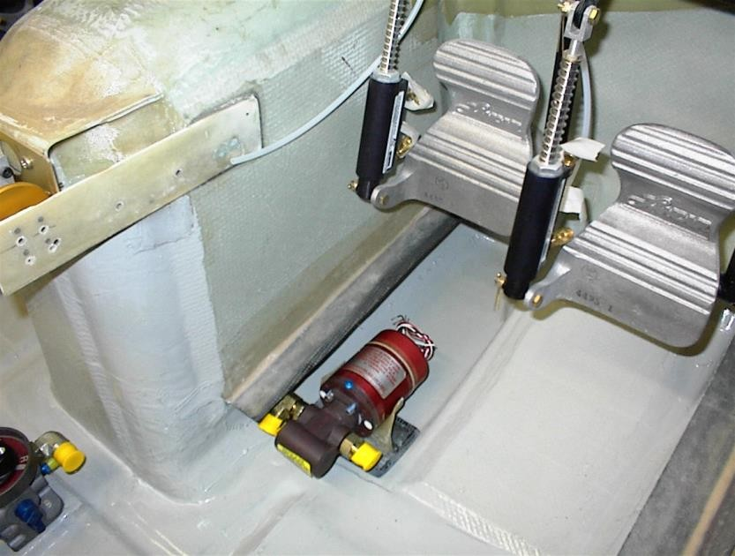

The sump should be drained often to keep water and debris out of the engine. Annually, it should be disassembled, cleaned and reassembled per the Veloce ANG drawings.

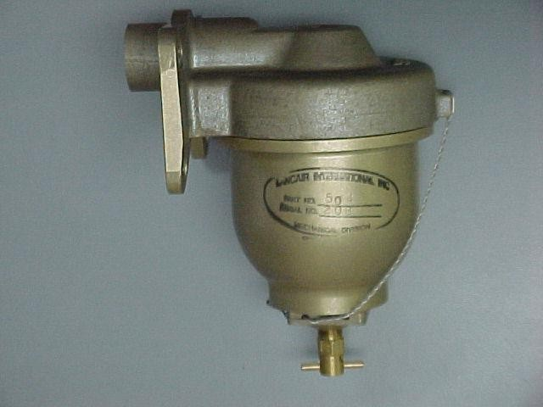

Fuel flows from the filter to the engine driven fuel pump on the accessory pad of the engine. Excess fuel returns to the fuel tank selected via a return fuel line.

HYDRAULIC

An 1100 psi hydraulic system operates the landing gear and flaps. The electrically powered hydraulic pump “power pack” is mounted on the aft side (left) of the 172 bulkhead accessed through the baggage door. A reservoir is located below and attached to the pump. Service the reservoir with MIL H 5606 hydraulic fluid. With the landing gear down and the flaps “up” the reservoir should be filled to within an inch of the filler neck.

An accumulator acts as a “shock absorber” in the system. A check of flap operation with the system “off” will tell you if the accumulator is working – you should be able to cycle the flaps up and down with pump off.
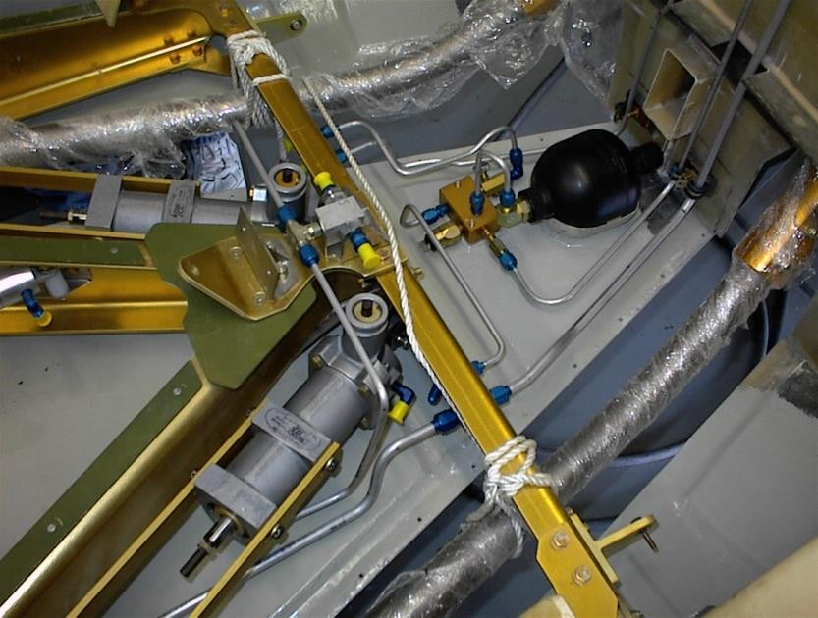

ENVIRONMENTAL

NON-PRESSURIZED

A heater muffler on the right engine exhaust stack provides for heated air to the cabin. A fresh air intake provides air to a mixer valve that combines the heatednair with a controlled quantity of unheated air to provide for the selected temperature. This air may then be routed for cabin heat, windshield defrost, or a combination of the two. Fresh ram air enters an intake on the right side of the vertical tail. An electric blower fan and ducting routes this fresh ram air to four overhead eyeball outlets. For ground operations, the blower maintains airflow through the system. Each outlet can be positioned to direct the flow of air as desired. A system shutoff valve is installed in the duct between the tail ram air scoop and the individual fresh air outlets.

PRESSURIZED
The Veloce ANG IV-P aircraft has a determined maximum pressure differential, (5PSID) which is the maximum differential between cabin and ambient altitudes that the pressurized section of the aircraft can support. Cabin pressurization is the compression of air in the aircraft cabin to maintain a cabin altitude lower than the actual flight altitude. At FL 250 and 5 psid the cabin altitude is maintained at 9,000’ MSL.
The pilot must be familiar with these limitations.
The cabin altitude can be manually selected and is monitored by a gauge, which indicated the pressure difference between the cabin and ambient altitudes. The rate of change between those two pressures is automatically controlled.
Compressed air is drawn from four calibrated sonic nozzles placed in the induction system. One set of two is located prior to the main intercooler. They supply hot pressurized air to the mixing or inflow valve.
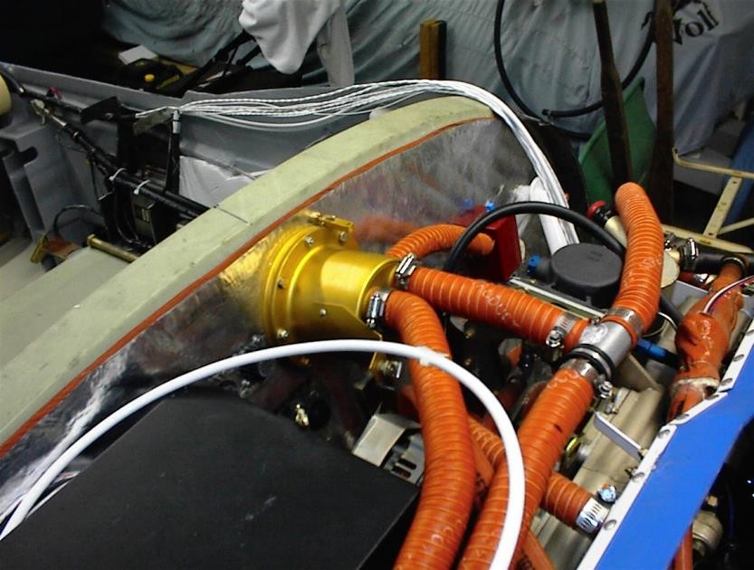

Another set of two nozzles draw pressurized air after the main intercoolers and is then routed to a cabin air intercooler just inside of the left cowling air inlet.
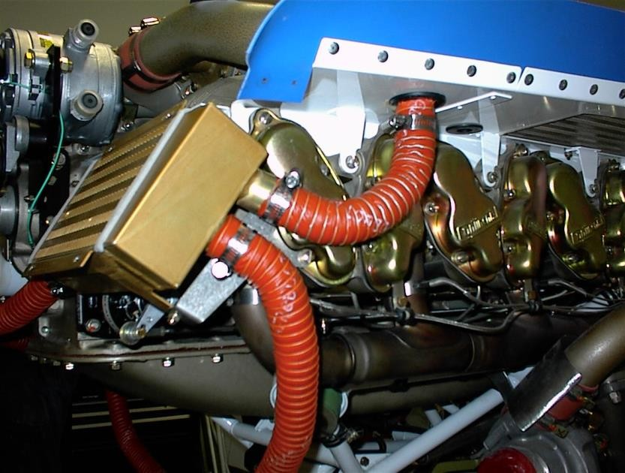

This air is also routed to the mixing valve. It is close to ambient air temperature. A cockpit control cable selects temperature from a mix of these two air supplies. Additionally, another control cable selects an overboard dump of all engine air for unpressurized flight, or for smoke in the induction system. The flow of compressed air into the cabin is regulated by an outflow valve that keeps the pressure constant by releasing excess pressure into the atmosphere.
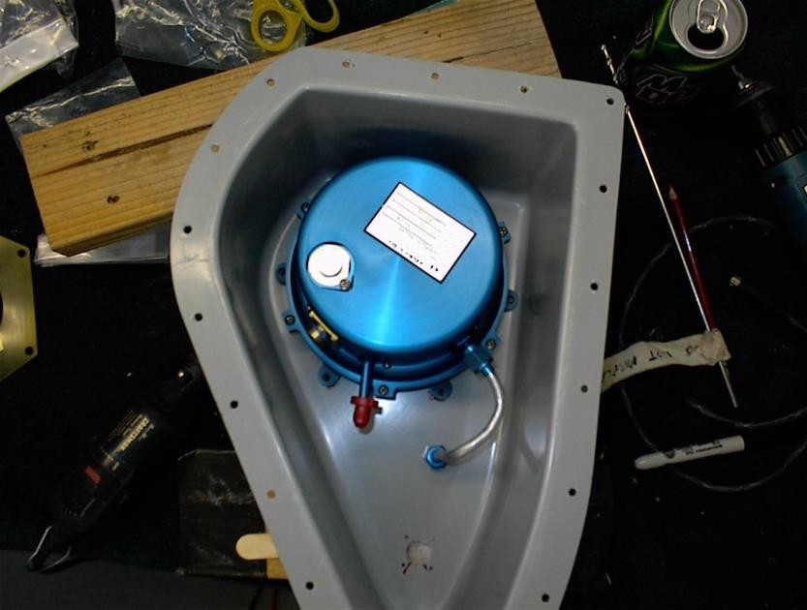

AIR CONDITIONING

Air Conditioning is an attractive option added by many builders. It may be a belly mounted Air Flow Systems unit or an aft bay mounted Veloce ANG system. The compressor on the belly scoop system is mounted on the engine and is belt driven. A refrigerant supply and return hose connects the compressor to the rest of the system.
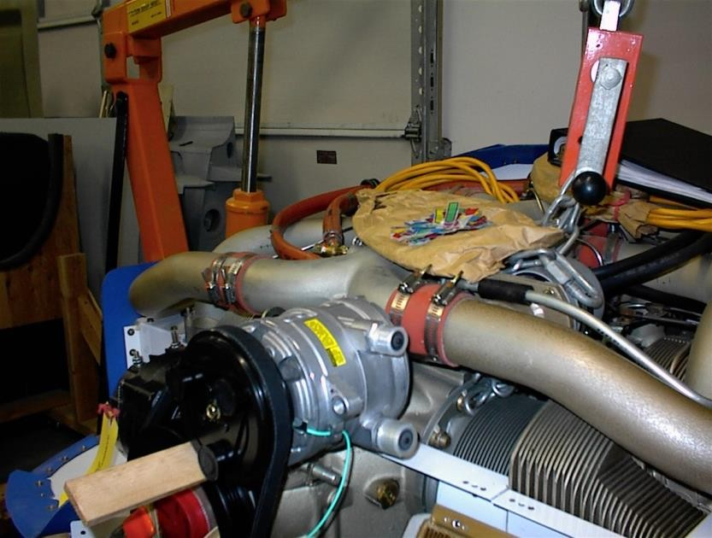

The condenser may be belly mounted making the Veloce ANG look somewhat like a P-51.
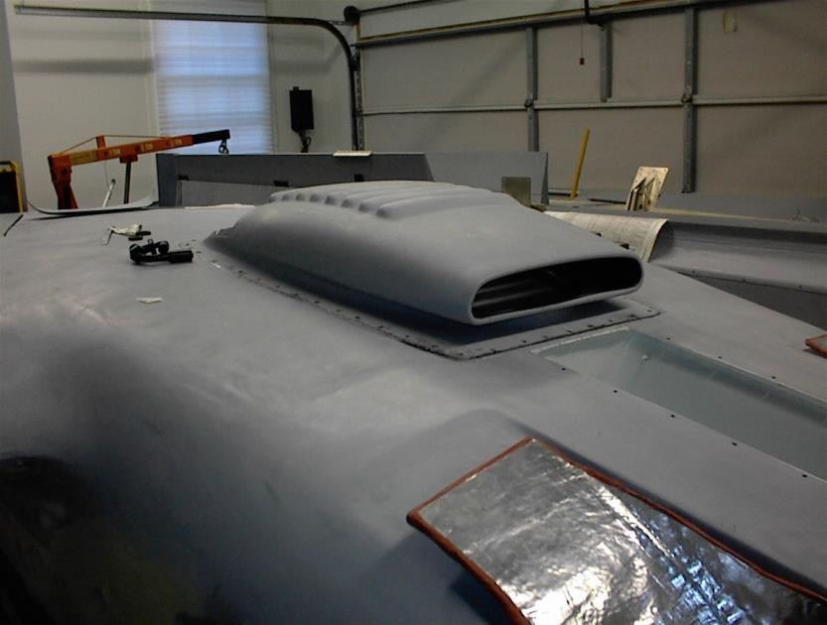

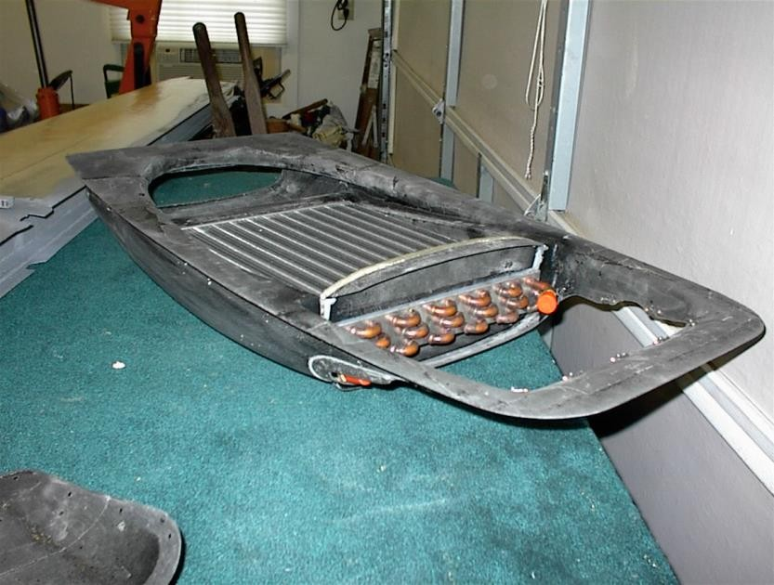

The evaporator is mounted in the aft cabin and supplies chilled air to the cabin. It is controlled by a switch on the instrument panel.
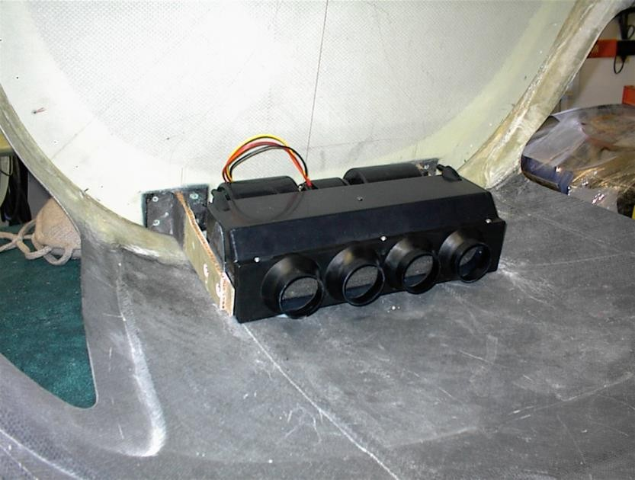

HIGH-ALTITUDE SYSTEMS AND EQUIPMENT
Several systems and equipment are unique to aircraft that fly at high altitudes, and pilots should be familiar with their operation before using them. Before any flight, a pilot should be familiar with all the systems on the aircraft to be flown.

Turbochargers
Turbochargers compress air in the intake to the cylinder by using exhaust gases from an engine-driven turbine wheel to drive a compressor. The increased air density provides greater power and improved performance. The turbocharger system allows the engine to develop higher than sea level pressure (up to 38.5 inches of manifold pressure) up to a critical altitude. To operate at altitudes below the critical altitude an automatic waste gate is installed in the turbocompressor to release unnecessary gas pressure. The waste gate is a damper-like device that controls the amount of exhaust that strikes the turbine rotor. As the waste gate closes with altitude, it sends more gases through the turbine compressor, causing the rotor to spin faster. This allows the engine to function as if it were maintaining sea level or, in the case of a supercharger, above sea level manifold pressure.

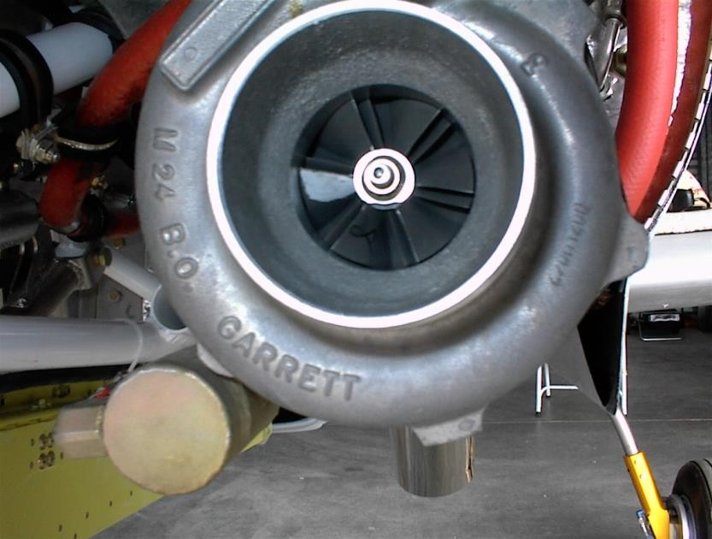

Automatic Waste Gate
Automatic waste gates operate on internal pressure. When internal pressure builds towards an overboost, the waste gate opens to relieve pressure, keeping the engine within normal operating limits regardless of the air density.
- The pressure-reference automatic waste gate system maintains the manifold pressure set b the throttle. Engine oil pressure moves the waste gate to maintain the appropriate manifold pressure, thus reducing the pilot’s workload and eliminating the possibility of overboost. If the airplane engine is started up and followed by an immediate takeoff, cold oil may cause a higher than intended manifold pressure. Allow the oil to warm up and circulate throughout the system before takeoff.
- The density-reference waste gate system is controlled by compressor discharge air. A density controller holds a given density of air by automatically adjusting manifold pressure as airspeed, ambient pressure, temperature, altitude, and other variables change.

Pressurized Magnetos
Thin air at high altitudes makes the unpressurized magneto susceptible to arcing or cross firing. The high-tension pressurized system is composed of sealed caps and plugs that keep the electrodes contained within the body. A pressure line extends directly from the upper deck to the magneto.
Pressurized magnetos perform better at high altitudes where low pressure and cold atmosphere have a detrimental effect on electrical conductivity. Flight above 14,000 feet with an unpressurized magneto should be avoided because of its high susceptibility to arcing. Once arcing has occurred, magneto overhaul is required to replace distributor blocks that have carbon traces.

Oxygen
Most high-altitude airplanes come equipped with some type of fixed oxygen installation. If the airplane does not have a fixed installation, portable oxygen equipment must be readily accessible during flight. For flights in pressurized aircraft above FL250 a 10 minute supply of supplemental O2 must be made available to each occupant in the event is necessitated by loss of cabin pressurization (14 CFR 91.211).The portable equipment usually consists of a container, regulator, mask outlet, and pressure gauge. A typical 22 cubic-foot portable container will allow four people enough oxygen to last approximately 1.5 hours at 1,800-2,200 pounds per square inch (PSI). The container should be fastened securely in the aircraft before flight. When the ambient temperature surrounding an oxygen cylinder decreases, pressure within that cylinder will decrease because pressure varies directly with temperature f the volume of a gas remains constant. Therefore, if a drop in indicated pressure on a supplemental oxygen cylinder is noted, there is no reason to suspect depletion of the oxygen supply, which has simply been compacted due to storage of the containers in an unheated area of the aircraft. High-pressure oxygen containers should be marked with the PSI tolerance (i.e. 1,800 PSI) before filling the container to that pressure. To assure safety, oxygen system periodic inspection and servicing should be done at FAA certified stations found at some fixed base operations and terminal complexes.

Regulator and Masks

Regulators and masks work on continuous flow, diluter demand, or on pressure demand systems. The continuous flow system supplies oxygen at a rate that may either be controlled by the user or controlled automatically on some regulators. The mask is designed so the oxygen can be diluted with ambient air by allowing the user to exhale around the face piece, and comes with a rebreather bag which allows the individual to reuse pat of the exhaled oxygen.
The pilot’s mask sometimes allows greater oxygen flow than passenger’s masks. Although certified up to 41,000 feet, very careful attention to system capabilities is required when using continuous flow oxygen systems above 25,000 feet.

Diluter Demand and Pressure Demand Systems
Diluter demand and pressure demand systems supply oxygen only when the user inhales through the mask. An automatic lever allows the regulators to automatically mix cabin air and oxygen, or supply 100% oxygen, depending on the altitude. The demand mask provides a tight sea over the face to prevent dilution with outside air, and can be used safely up to 40,000 feet. Pilots who fly at those altitudes should not have beards and moustaches because air can easily seep in through the border of the mask. Pressure demand regulators also create airtight and oxygen tight seals, but they also provide a positive pressure application of oxygen to the mask face piece, which allows the user’s lings to pressurize with oxygen. This feature makes pressure demand regulators safe at altitudes above 40,000 feet.

Fire Danger
Pilots should be aware of the danger of fire when using oxygen. Materials that are nearly fireproof in ordinary air may be susceptible to burning in oxygen. Oils and greases, such as lipstick or ChapStick, may catch fire if exposed to oxygen. Oil should not be used for sealing the valves and fittings of oxygen equipment. Smoking during any kind of oxygen equipment use must also be strictly forbidden.

